PENNE ALLA VODKA  COOK TIME: 20 min  SOURCE:  #comfort-food #pasta #sauce | 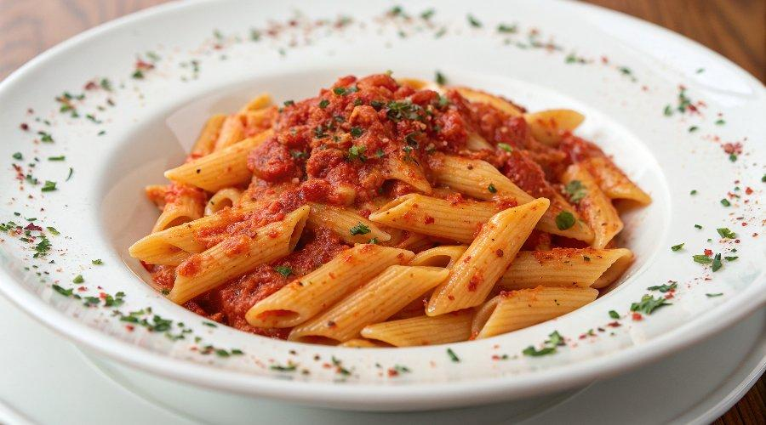

INGREDIENTS  - 16 oz penne pasta  - 2 tbsp butter  - 2 tsp garlic  - 1/2 tsp crushed red pepper flakes (plus more for garnish if desired)  - 28 oz can Italian style or San Marzano whole tomatoes  - 1/4 cup vodka  - 1 cup (240ml) heavy cream  - 3/4 cup grated parmesan cheese (plus more for serving)  - salt and pepper to taste  - 2 tbsp chopped parsley | PREP  COOK  1. Cook the pasta in salted boiling water according to package directions.  2. While the pasta is cooking, prepare the sauce.  3. Melt the butter in a large pan over medium heat. Add the garlic and red pepper flakes and cook for 30 seconds.  4. Place the tomatoes in a blender or food processor and puree until smooth. Pour the tomato puree into the pan.  5. Add the vodka to the pan. Simmer the sauce for 10 minutes over medium low heat.  6. Stir in the heavy cream and parmesan cheese and simmer for another 5 minutes or until thickened. Season the sauce with salt and pepper to taste.  7. Pour the sauce over the pasta and toss to coat. Sprinkle with parsley, parmesan cheese and red pepper flakes (optional), then serve.  PLATING

