BASA FILLET WITH GARLIC, SPRING ONION & PAPRIKA BUTTER  COOK TIME: 10 min  SOURCE:  #quick #comfort-food #fish | 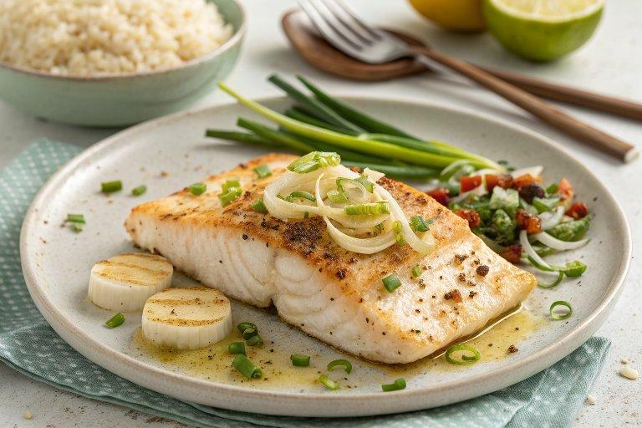

INGREDIENTS  - 1 tbsp olive oil  - 2 tbsp plain flour  - 2 basa fillets (ours weighed 250 g in total)  - 50 g salted butter  - 3 spring onions finely sliced  - 2 garlic cloves grated  - 1 tsp smoked sweet paprika  - cooked rice or potatoes and veg to serve | PREP  COOK  1. Pour the olive oil into a frying pan over a medium heat. Put the flour on a plate and season with salt and pepper, then season the basa fillets. Dip the basa in a light coating of the flour, shaking off the excess.  2. Once the oil is hot lower in the fish and cook for 2-3 mins on each side until lightly golden and the fish flakes when pressed. Remove and drain on kitchen paper.  3. Melt the butter in the pan on a medium heat. Once foaming, stir in the spring onions and garlic with a small pinch of salt and a good few twists of black pepper. Cook for 1-2 mins, then scatter in the paprika and toast for 30 seconds, stirring well to combine. Pour over the fish and serve with rice or potatoes and vegetables.  PLATING

