SIMPLE PEACH, BASIL AND RICOTTA FLATBREAD  COOK TIME: 15 min  SOURCE:  #quick #fresh #light | 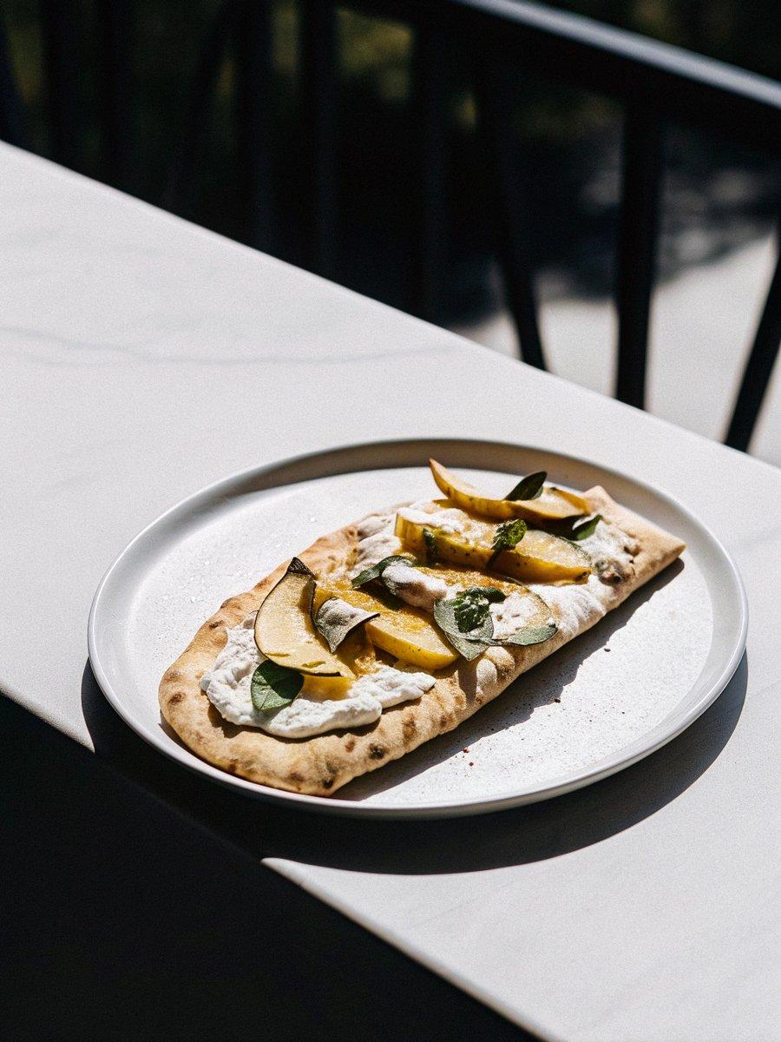

INGREDIENTS  - 2 store-bought whole wheat flatbreads or naan  - 2/3 cup ricotta (enough to generously cover the top of each flatbread, this amount is dependent on the size of your flatbreads)  - 1 to 2 ripe yellow peaches, peeled and sliced (I only needed one)  - 2 tsp fresh basil, chopped (a few big basil leaves’ worth)  - sea salt and black pepper  - balsamic vinegar reduction, for drizzling (see notes) | PREP  COOK  1. Preheat the oven to 425°F (220°C). Place the flatbread in a cast iron pan or baking sheet.  2. Spread ricotta evenly across the flatbread, leaving ½ inch around the edges. Place slices of peach on the ricotta.  3. Bake for 10 to 12 minutes. Sprinkle with chopped basil, sea salt and freshly ground black pepper. Slice, then drizzle with balsamic reduction before serving.  PLATING

