FRESH STRAWBERRY PIE  COOK TIME: 30 min  SOURCE:  #sweet #fruit #pie | 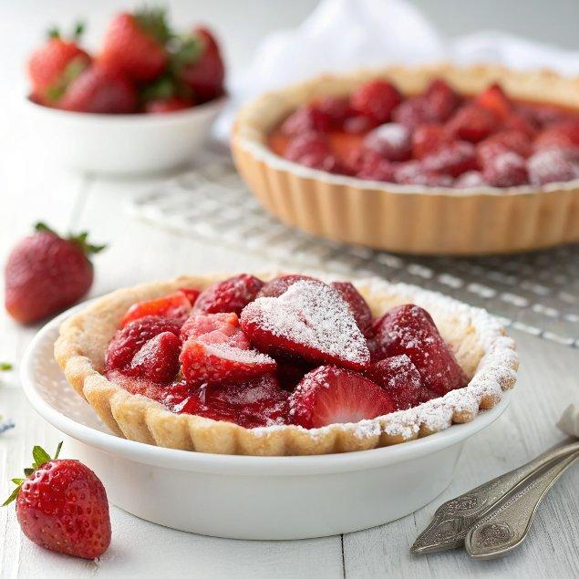

INGREDIENTS  - Chilled pie dough for one 9-inch (23cm) pie (see our pie crust recipe)  - 1 1/2 lb (680 g) quartered and hulled strawberries, 5 cups (1200ml)  - 2/3 to 3/4 cup (135 g to 150 g) sugar, adjusted according to the sweetness of the strawberries  - 1/4 cup (30 g) cornstarch  - 1 tsp vanilla extract  - 1/4 tsp almond extract  - 1 tbsp lemon juice  - 1/8 tsp salt  - 1 egg yolk  - 1 tbsp cream  - Homemade whipped cream or whipped coconut cream | PREP  COOK  1. Pre-Bake Pie Crust  2. Roll out the pie dough to fit your pie dish. Gently press the dough down into the dish to line the bottom and sides. (Be careful not to pull or stretch the dough.) Then, use a knife or pair of kitchen scissors to trim the dough to within 1/2-inch (5cm) of the edge of the dish.  3. Fold the edges of the dough underneath itself, creating a thicker, 1/4-inch (10cm) border that rests on the lip of the dish. Then, crimp the edges.  4. Pierce the bottom of the crust with a fork (this prevents air pockets or bubbles from forming while baking). Then, line the crust with two sheets of aluminum foil and fill the foil with dried rice, dried beans, or pie weights. Refrigerate 30 minutes or until firm to the touch.  5. While the crust is chilling, preheat the oven to 425°F (220°C). Place a baking sheet on a middle oven rack.  6. Place the pie crust on the preheated baking sheet and reduce the oven temperature to 400°F (200°C). Bake for 20 to 30 minutes or until the crust is golden.  7. Remove the rice, beans, pie weights, and foil from the pie crust.  8. Make an egg wash by whisking the egg yolk and cream in a small bowl. Brush the bottom and sides of the crust with egg wash. Bake until the egg wash is dry and shiny, 3 to 5 minutes. Cool the crust completely before filling.  9. Make Strawberry Pie  1  0. Make the strawberry glaze by mashing 2 cups (480ml) of the strawberries in a small saucepan until chunky.  1  1. Add the sugar, cornstarch, vanilla extract, almond extract, lemon juice, and salt. Bring to a simmer over medium heat and cook, stirring occasionally, until the sugar dissolves and glaze has thickened, about 5 minutes. Cool completely.  1  2. Fold the remaining 3 cups (720ml) of strawberries into the cooled glaze until well coated. Spoon the strawberry filling into the cooled pie crust.  1  3. Refrigerate the strawberry pie for at least 2 hours before cutting to allow the filling to set (remember it won’t set as firmly as jello).  1  4. Top with whipped cream.  PLATING

