PEKING SHREDDED PORK WITH SWEET BEAN SAUCE (京酱肉丝)  COOK TIME: 6 min  SOURCE:  #quick #comfort-food #stir-fry | 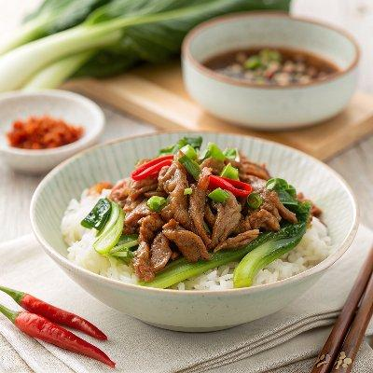

INGREDIENTS  - 400 g pork tenderloin (aka pork fillet) (about 14 oz)  - 2 tsp light soy sauce  - 2 tsp Shaoxing rice wine  - 1 tsp cornstarch  - 1/4 tsp salt  - 1 pinch ground white pepper  - 2 tbsp water  - 1 tsp neutral cooking oil  - Scallions, the white part only  - Cucumber  - Tofu sheets (or duck pancakes (see note 1 & 2)  - 3 tbsp sweet bean sauce (Tian Mian Jiang/甜面酱) (see note 3)  - 1 tbsp Shaoxing rice wine  - 1 tbsp sugar  - 2 tbsp water  - 3 tbsp neutral cooking oil | PREP  COOK  1. Marinate the pork  2. Use a sharp knife, cut pork, across the grain, into narrow strips. Then put it into a bowl. Add light soy sauce, Shaoxing rice wine, cornstarch, salt, white pepper and water.  3. Use your fingers or chopsticks to agitate until the liquid is fully absorbed and the meat becomes sticky. Pour in 1 teaspoon of oil and mix to coat. Leave to marinate for 10 minutes or so.  4. Prepare the accompaniments  5. Julienne the white part of the scallions. Peel the cucumber and remove its seeds, then cut it into thin strips.  6. Cut tofu sheets into squares (similar size to wonton wrappers). Blanch them in boiling water for 2 minutes. Drain then leave to dry.  7. Mix the sauce  8. In a bowl, mix sweet bean sauce, Shaoxing rice wine, sugar and water until smooth. Set aside.  9. Stir-fry the dish  1  0. Heat a wok (or a deep frying pan/skillet) until very hot then add 3 tablespoons of oil (if using non-stick cookware, add oil first then heat up).  1  1. Put in the marinated pork. Use chopsticks to loosen the strips. Then toss constantly to fry evenly. As soon as the meat turns pale, transfer out leaving any oil in the wok.  1  2. Turn the heat to low. Pour the sauce mixture into the wok and leave to simmer.  1  3. Once the sauce starts to thicken, return the pork to the wok. Toss to evenly coat it with the sauce.  1  4. Serve the dish  1  5. Transfer the pork to a serving plate and put tofu sheets, scallions and cucumber on the side.  1  6. Place some scallions, cucumber and pork strips over a piece of tofu sheet. Roll up and enjoy!  PLATING

