5-INGREDIENT SWEET POTATO CURRY  COOK TIME: 21 min  SOURCE:  #quick #comfort-food #curry | 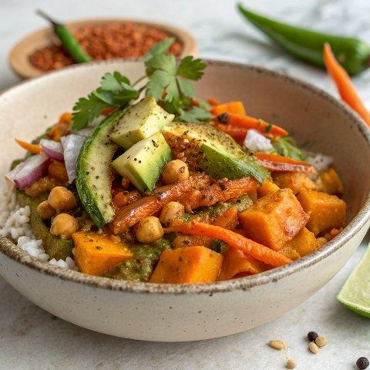

INGREDIENTS  - 1/2 tbsp avocado or coconut oil  - 1 large yellow onion (chopped)  - 4 tbsp green or red curry paste (I used green curry paste from Thai Kitchen)  - 1 medium-large sweet potato (peeled and chopped into bite-size chunks)  - 1 15 oz can chickpeas (drained and rinsed)  - 1 13.5 oz can coconut milk  - 1/2 cup water (if needed)  - optional: fresh chopped cilantro and fresh lime and rice (for serving) | PREP  COOK  1. Heat oil in a large skillet over medium-high heat. Add the onion to the skillet and cook, stirring frequently, for about 5-6 minutes or until fragrant. Add curry paste to the skillet, toss and sauté for another minute.  2. Add sweet potatoes, chickpeas and coconut milk to the skillet and stir to combine.  3. Allow the sauce to heat up until it is simmering and let simmer for about 10-15 minutes or until sweet potatoes are tender enough to be easily pierced with a fork. If the mixture gets too thick (or dry) you can add water to the pan, 1/4 cup at a time, up to 1/2 cup. Taste and season with salt and pepper, if needed.  4. Serve curry over rice with cilantro and a squeeze of lime.  PLATING

