SALMON MEUNIERE  COOK TIME: 10 min  SOURCE:  #quick #comfort-food #fish | 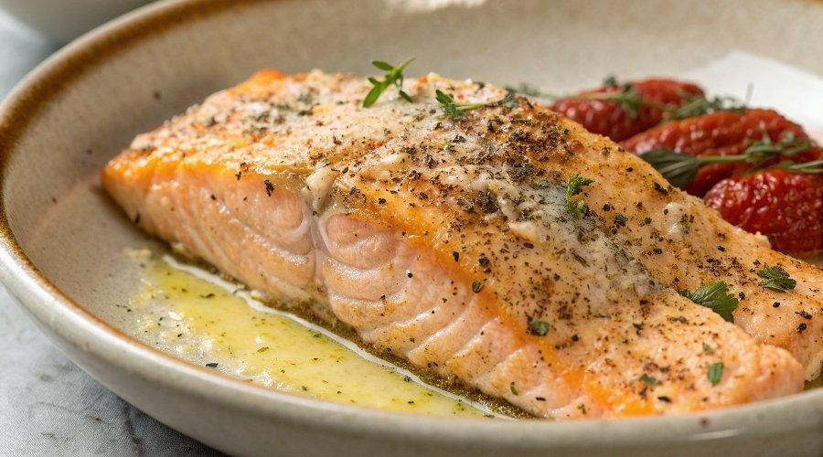

INGREDIENTS  - 1/4 cup all-purpose flour  - 1 1/4 tsp kosher salt (divided)  - 1/2 tsp ground black pepper  - 2 6-oz salmon fillets, skins removed  - 2 tbsp unsalted butter  - 1/2 tsp grated lemon zest (about 1/2 lemon)  - 3 tbsp freshly squeezed lemon juice (about 1 small lemon)  - 1 tbsp finely chopped fresh parsley  - 1 tbsp drained capers | PREP  COOK  1. Place a rack in the center of your oven and preheat to 425°F (220°C).  2. In a large, shallow plate (a pie dish works well), combine the flour, 1 teaspoon salt, and pepper. Pat the salmon fillets dry with paper towels and sprinkle the remaining ¼ teaspoon salt over the top.  3. Melt the butter in a large (12-inch) oven safe cast iron skillet or similar sturdy-bottomed oven safe skillet over medium heat. Continue to heat, swirling the pan periodically, until it begins to brown.  4. Reduce the heat to medium-low. Dredge both sides of the salmon fillets in the flour mixture. Shake off the excess then gently place them in the hot butter, top-side down. Cook without disturbing them for 3 minutes, until the top is golden brown. When the salmon turns opaque on the sides and starts to turn opaque on top, use a flexible spatula to flip the salmon.  5. Add the lemon zest and lemon juice to the pan. Place the skillet immediately into the oven and let cook for 6 minutes (the salmon will appear a little undercooked in the center but will finish cooking as it rests). Remove from the oven and cover with foil. Let rest 4 to 5 minutes.  6. To serve, place each piece of salmon on a plate and spoon the pan sauce liberally over the top. Sprinkle with fresh parsley and capers. Season with additional salt and pepper to taste. Enjoy immediately.  PLATING

