CHOCOLATE CHIP COOKIE LAYER CAKE  COOK TIME: 22 min  SOURCE:  #baking #sweet #comfort-food | 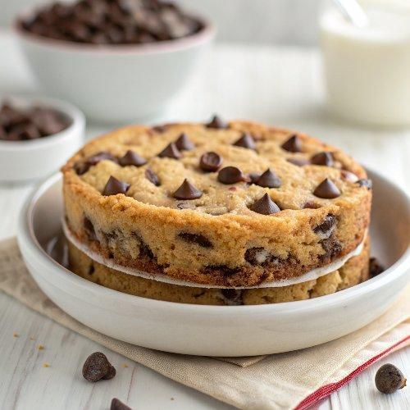

INGREDIENTS  - 3 cup (720ml)s (375 g) all-purpose flour (spooned & leveled)  - 2 tsp cornstarch  - 1 tsp baking soda  - 1 tsp salt  - 1 cup (16 Tbsp; 226 g) unsalted butter, softened to room temperature  - 1 cup (200 g) packed light or dark brown sugar  - 1/2 cup (100 g) granulated sugar  - 2 large eggs, at room temperature  - 2 and 1/2 tsp pure vanilla extract  - 2 cup (480ml)s (360 g) semi-sweet chocolate chips (I used mini), plus extra for garnish  - 1 cup (16 Tbsp; 226 g) unsalted butter, softened to room temperature  - 1/2 cup (130 g) creamy peanut butter*  - 3 and 1/2 cups (420 g) confectioners’ sugar  - 1/2 cup (41 g) unsweetened natural or dutch-process cocoa powder  - 1 tsp pure vanilla extract  - 1-2 tbsp milk  - salt, to taste | PREP  COOK  1. Preheat oven to 350°F (177°C). Grease 6-inch (15cm) cake pans, line with parchment paper rounds, then grease the parchment paper. Parchment paper helps the cakes seamlessly release from the pans. (If it’s helpful, see this parchment paper rounds for cakes video & post.)  2. Make the cookie cake  3. Whisk the flour, cornstarch, baking soda, and salt together in a medium bowl. Set aside.  4. In a large bowl using a hand mixer or a stand mixer fitted with a paddle attachment, beat the butter, brown sugar, and granulated sugar together on medium-high speed until smooth and creamed, about 2 minutes. Add the eggs and vanilla extract and beat on high speed until combined, about 1 minute. Scrape down the sides and up the bottom of the bowl and beat again as needed to combine.  5. Add the dry ingredients to the wet ingredients and mix on low until combined. With the mixer running on low speed, beat in the chocolate chips. Dough will be thick and sticky.  6. Divide cookie dough between however many cake pans you’re using. Press evenly into each. I only have 3 6-inch (15cm) cake pans, so I baked in batches. If baking in batches, cover any cookie dough that isn’t being used and set aside at room temperature.  7. Bake for 20-22 minutes or until the cake layers are lightly brown on top and a toothpick inserted in the center comes out mostly clean. Allow cakes to cool for 10 minutes in the pans. Run a sharp knife around the edges, then carefully invert the pan so the warm cookie cake slides out. (At this point you can clean out pans, grease, line with parchment, grease parchment, then bake remaining cakes if needed.) Set the baked cakes on a wire rack to cool completely. The cakes must be completely cool before frosting and assembling.  8. Make the frosting:  9. With a handheld or stand mixer fitted with a paddle or whisk attachment, beat the butter and peanut butter together on medium speed until creamy and smooth, about 2 minutes. Add confectioners’ sugar, cocoa powder, vanilla extract, and 1 Tablespoon milk. Mix on low speed for 30 seconds, then increase to high speed and beat for 2 minutes. Add another Tablespoon or 2 of milk if frosting is too thick. Taste and add a pinch of salt if needed. (I always add a pinch!)  1  0. Assemble and decorate  1  1. Place 1 cake layer on your cake stand, cake turntable, or serving plate. Evenly cover the top with frosting. Continue layering the cake layers and frosting. Spread the remaining frosting all over the top and sides, if there’s any leftover for the sides! If desired, top with chocolate chips. Slice and serve.  1  2. Cover leftover cake tightly and store in the refrigerator for 5 days.  PLATING

