KASHMIRI STYLE VETH CHAMAN RECIPE-PANEER IN YOGURT & TOMATO CURRY  COOK TIME: 20 min  SOURCE:  #comfort-food #curry #spicy | 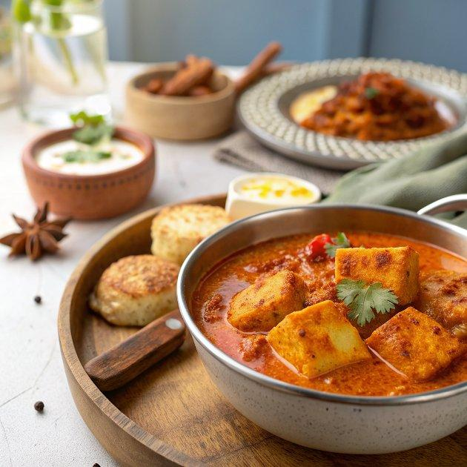

INGREDIENTS  - 300 g Paneer (Homemade Cottage Cheese) diced in cubes  - 1 1/2 cup Water  - pinch Asafoetida (hing)  - 2 Cinnamon Stick (Dalchini)  - 5 Cardamom (Elaichi) Pods/Seeds  - 2 Bay leaves (tej patta)  - 1/2 cup Homemade tomato puree  - 1/2 tsp Ajwain (Carom seeds)  - 1/2 tsp Kashmiri Red Chilli Powder  - 1.5 tsp Fennel seeds (Saunf) grounded to make powder  - 2 tbsp Curd (Dahi / Yogurt) whisked  - pinch Saffron strands  - 1/2 tsp Dry ginger powder  - pinch Mixed Spices  - 4 tbsp Mustard oil  - Salt to taste  - Coriander (Dhania) Leaves for garnishing | PREP  COOK  1. To begin making the Kashmiri Veth Chaman, heat 2 tablespoons mustard oil in a thick bottomed pan and fry the cubes of cottage cheese until it turns golden brown color. Drain on absorbent paper.  2. Meanwhile In a bowl, add one and a half cup of warm water and then put the fried paneer to the warm water.  3. Now in a pan add the remaining mustard oil, add asafoetida and let it sizzle for a second.  4. Now add cinnamon sticks, bay leaves and green cardamom, saute them for few seconds.  5. Add shahi jeera and saute for another few seconds. Then add tomato puree in it.  6. Now add kashmiri red chilli powder, ginger powder and mix well.  7. Next add freshly grounded fennel powder and mix it properly. At this time add half cup of soaked paneer liquid and mix well (you may add more or less water as your choice).  8. When the mixture starts to boil, add whisked yogurt, crushed saffron and combine them well.  9. Simmer the gravy for a further 5 minutes then add salt and mix well. Now add soaked paneer cubes carefully because they are very soft now. Cover and let Kashmiri Veth Chaman it simmer for 1 or 2 minutes.  1  0. Now sprinkle mixed spice or garam masala and garnish Kashmiri Veth Chaman with fresh coriander leaves.  1  1. The Kashmiri Veth Chaman can be served with Mixed Vegetable Pulao Recipe or lachha paratha or simple phulkas for a delicious meal.  PLATING

