VEGAN BLOOD ORANGE UPSIDE-DOWN CAKE  COOK TIME: 50 min  SOURCE:  #baking #fruit #cake | 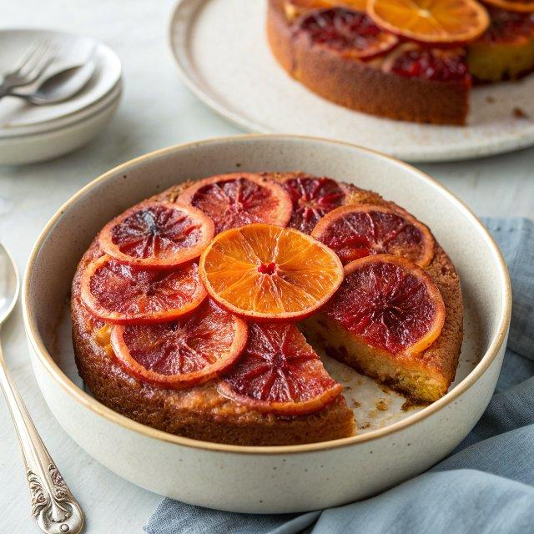

INGREDIENTS  - 5-6 medium blood oranges  - 1 1/2 tbsp vegan butter (or extra-virgin olive oil)  - 3 tbsp organic cane sugar (or raw sugar or demerara sugar)  - 1 3/4 cups all-purpose flour  - 2 tsp baking powder  - 1/4 heaping tsp fine sea salt  - 1 cup (240ml) plant-based milk (I used low-fat Oatly oat milk, but almond milk would work great as well)  - 1/3 cup extra-virgin olive oil  - 3/4 cup + 2 tbsp organic cane sugar  - 1 tbsp apple cider vinegar  - 1 tsp almond extract (omit for nut-free, or just add more vanilla extract)  - 1 tsp vanilla extract | PREP  COOK  1. Preheat oven to 350° (177°C).  2. Grease a 9-inch (23cm) springform pan with the 1 ½ tablespoons vegan butter (or extra-virgin olive oil). Sprinkle the 3 tablespoons cane sugar evenly on top of the butter, tapping the pan on the counter and tossing around to coat evenly on the bottom and a bit on the sides.  3. Peel the blood oranges and then slice them into 1/8 to 1/4-inch (10cm) rounds. Arrange the oranges in concentric circles in the bottom of the pan, overlapping them as needed to cover all the open spaces and gaps (you can cut oranges in half to do this).  4. In a large bowl, mix together flour, baking powder, salt.  5. In a medium bowl, whisk together plant-based milk, ⅓ cup extra-virgin olive oil, ¾ cup + tablespoons sugar, apple cider vinegar, almond extract, and vanilla extract until smooth.  6. Pour the wet ingredients into the dry ingredients and gently mix with a wooden spoon until combined and no flour clumps remain.  7. Pour the cake batter on top of the orange slices in the pan and smooth out with a rubber spatula. Tap the cake pan on the surface to remove any air pockets.  8. Bake the cake for 50-55 minutes, or until a toothpick comes out with just a few crumbs. The cake should be tender, fluffy, and moist.  9. Allow the cake to cool in the pan for 15 minutes, then unclasp the spring and carefully invert the cake onto a wire rack to further cool.  PLATING

