YANG ZHOU FRIED RICE (扬州炒饭)  COOK TIME: 10 min  SOURCE:  #quick #comfort-food #fried-rice | 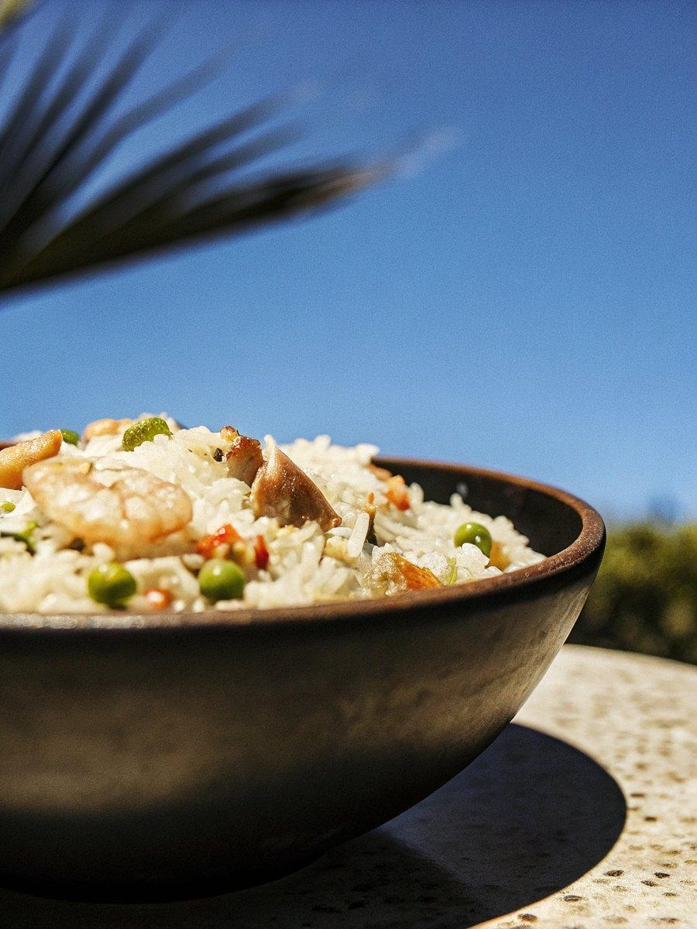

INGREDIENTS  - 2 1/2 tbsp peanut oil (or vegetable oil)  - 4 oz char siu pork , diced (or ham, or sausage)  - 6 oz shrimp , peeled and deveined (*Footnote 1)  - 1/2 cup frozen vegetable mix , thawed (I used frozen green peas)  - 4 cups (960ml) leftover cooked white rice (*Footnote 2)  - 1 tbsp light soy sauce  - 2 large eggs , beaten  - 1/2 tsp salt (or to taste)  - 1/4 tsp ground white pepper  - 4 green onions , chopped | PREP  COOK  1. Heat 1/2 tablespoon of oil in a wok or a nonstick skillet over medium-high heat until hot. Swirl to coat the bottom of the pan with the oil. Add the ham and shrimp. Cook for 30 seconds without disturbing. Stir and cook until the shrimp turn white. Immediately transfer the ham and shrimp to a separate plate.  2. Add 1 tablespoon of oil and the rice. Stir and cook for 1 minute to coat the rice with oil. Pour in the soy sauce. Stir and cook until the soy sauce is evenly distributed. And the grains are separated.  3. Move the rice to one side of the pan and add oil and the beaten eggs to the other side. Let cook for 30 seconds until the bottom is just set. Stir gently to scramble the eggs, then mix the rice with the eggs. Stir and cook until the eggs are separated into small pieces, 1 to 2 minutes.  4. Add the vegetable mix and green onion. Sprinkle salt and white pepper. Stir and cook for another minute.  5. Return the cooked shrimp and char siu. Give it a final mix. Turn to low heat, carefully taste the rice and adjust seasoning if necessary. Transfer to serving bowls and serve hot as a side dish, or a light main dish.  PLATING

