KARAAGE RICE BOWL  COOK TIME: 30 min  SOURCE:  #fried #comfort-food #quick | 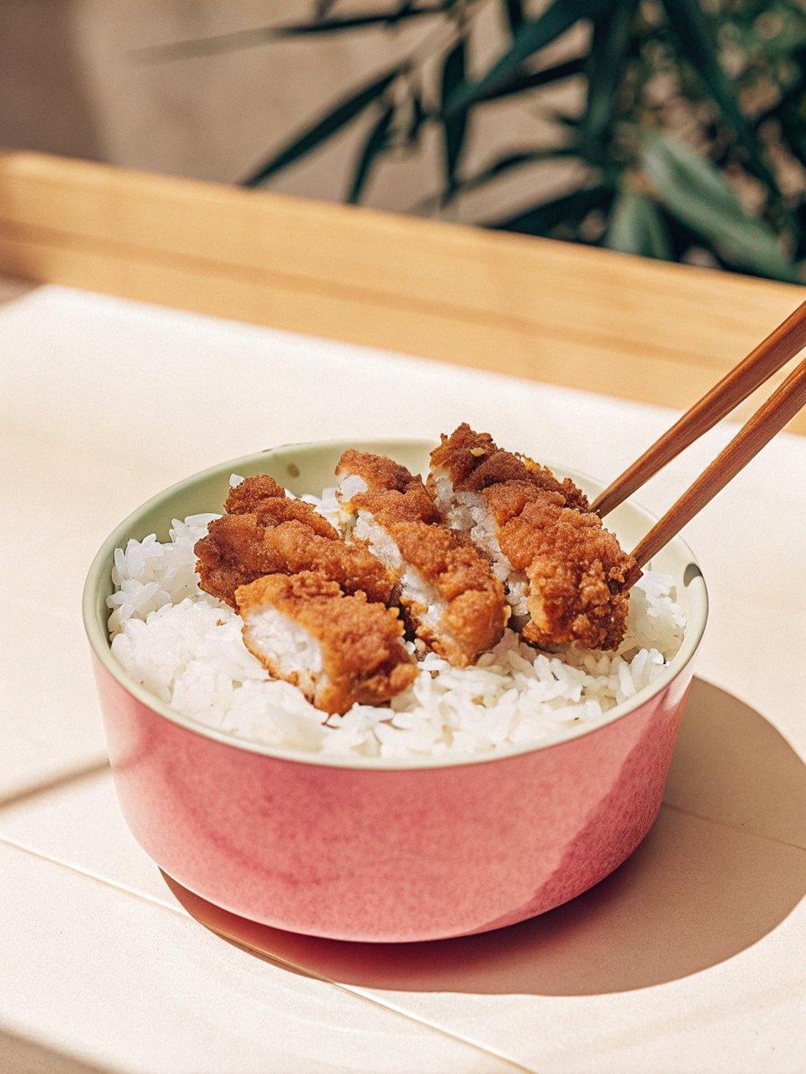

INGREDIENTS  - 2 boneless, skinless chicken breasts (roughly 1 lb, 454 g; or 4 chicken thighs) 1 454 4  - 1/3 cup all-purpose flour (plain flour)  - 1/3 cup potato starch or cornstarch  - 3 cups (720ml) neutral oil (for deep frying)  - 3 servings cooked Japanese short-grain rice (typically 1 2/3 cups (250 g) per donburi serving)  - 2 cloves garlic  - 1 tsp ginger (grated, with juice)  - 1 Tbsp sake  - 1 Tbsp tianmianjiang (sweet bean sauce)  - 1 tsp soy sauce  - 1 tsp toasted sesame oil  - 1 large egg yolk  - 1/4 tsp Diamond Crystal kosher salt  - freshly ground black pepper  - 1 Tbsp soy sauce  - 1/2 Tbsp toasted sesame oil  - la-yu (Japanese chili oil) (optional; you can make my Homemade La-yu)  - Japanese Kewpie mayonnaise  - shredded nori seaweed (kizami nori)  - 2 green onions/scallions | PREP  COOK  1. Before You Start: Gather all the ingredients. For the steamed rice, please note that 2¼ cups (450 g, 3 rice cooker cups) of uncooked Japanese short-grain rice yield 6⅔ cups (990 g) of cooked white rice, enough for 3 donburi servings (5 cups, 750 g). See how to cook short-grain rice with a rice cooker, pot on the stove, Instant Pot, or donabe.  2. Butterfly and cut 2 boneless, skinless chicken breasts in half. I also separate out the chicken tenders.  3. Pound the chicken to equal thickness with a meat tenderizer or the back of a knife. Then cut into ½-inch-wide strips.  4. Put the chicken pieces in a large bowl. Mince or crush 2 cloves garlic and add to the bowl. Add 1 tsp ginger (grated, with juice).  5. Add the rest of the ingredients for seasonings: 1 Tbsp sake, 1 Tbsp tianmianjiang (sweet bean sauce), 1 tsp soy sauce, 1 tsp toasted sesame oil, 1 large egg yolk, ¼ tsp Diamond Crystal kosher salt, and freshly ground black pepper. Mix and coat the chicken well with the marinade. Keep in the refrigerator for 30 minutes or longer.  6. Combine ⅓ cup all-purpose flour (plain flour) and ⅓ cup potato starch or cornstarch in a medium bowl and whisk well together.  7. Heat 3 cups (720ml) neutral oil to 325–340ºF (163–171ºC) on medium heat in a saucepan or wok. Check to see if the oil is ready for deep-frying. Put a chopstick in the oil and when you see the bubbles around it, it’s ready!  8. Coat a piece of chicken in the flour mixture and dust off the excess flour. Place 5 chicken pieces slowly into the oil in the wok. Do not crowd the wok.  9. Deep-fry the chicken over medium heat for about 4–5 minutes. If the chicken gets brown too quickly, take it out and lower the oil temperature by reducing the heat a little bit and put the chicken back in.  1  0. When the chicken is cooked and nicely brown, transfer to a wire rack or paper towel to drain excess oil. Make sure to pick up foams and crumbs between batches. The crumbs in the oil make the oil darker, so frequently skim it with a fine-mesh skimmer.  1  1. For garnish, cut 2 green onions/scallions into small pieces. To make the sauce, combine 1 Tbsp soy sauce, ½ Tbsp toasted sesame oil, and the optional la-yu (Japanese chili oil) in a small bowl.  1  2. Serve 3 servings cooked Japanese short-grain rice in individual large donburi bowls and place the chicken on top.  1  3. Drizzle the sauce and Japanese Kewpie mayonnaise on top.  1  4. Garnish with shredded nori seaweed (kizami nori) and the chopped green onions. Serve immediately and enjoy!  PLATING

