GRILLED HARISSA LAMB CHOPS  COOK TIME: 10 min  SOURCE:  #grilled #lamb #spicy #main-course | 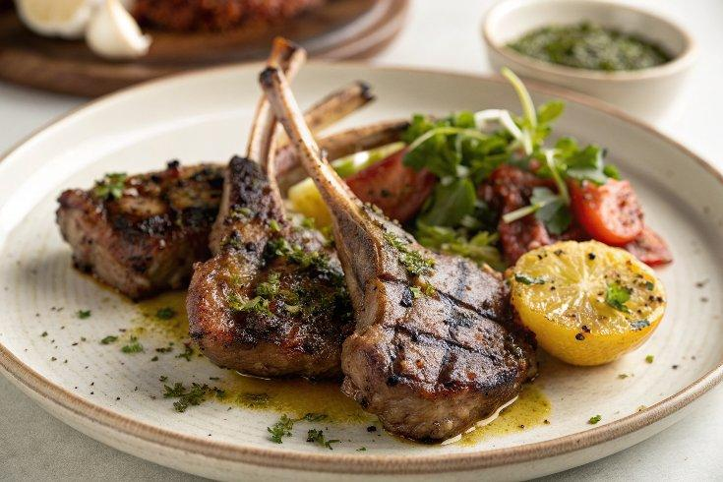

INGREDIENTS  - 8 lamb loin chops on the bone (about 3-1/2 oz each, all fat trimmed off)  - 2 tbsp fresh lemon juice  - 4 cloves garlic (crushed)  - 3/4 tsp ground cumin  - 2 tbsp prepared Harrisa  - kosher salt and fresh ground pepper (to taste) | PREP  COOK  1. Place the lamb chops in a large bowl and squeeze the lemon juice over them.  2. Add the crushed garlic, cumin, Harissa and season with salt and pepper, to taste.  3. Cover with plastic wrap and marinate at least 1 hour, or as long as overnight.  4. Spray the grill rack or a grill pan with oil; preheat the grill or grill pan to medium-high heat.  5. Grill the chops about 4 to 6 minutes on each side, or until an instant-read thermometer inserted in the side of each chop registers 145°F (65°C) for medium-rare, or longer if you like your meat more well done.  PLATING

