SKILLET SEARED STEAK WITH GARLIC BUTTER  COOK TIME: 10 min  SOURCE:  #quick #comfort-food #grilled | 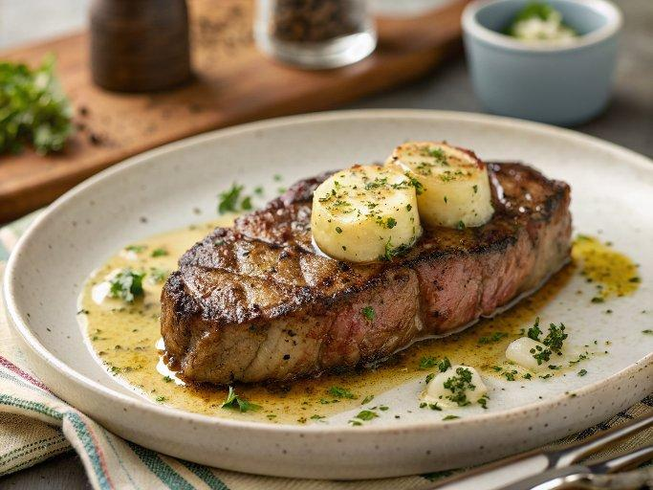

INGREDIENTS  - 2 (12 oz) Ribeye or New York strip steaks ((about 1 1/4-inches thick))  - 1 Tbsp vegetable oil  - 1 tsp kosher salt  - 3/4 tsp freshly ground black pepper  - 2 Tbsp unsalted butter  - 2 sprigs fresh thyme  - 2 garlic cloves, (peeled and smashed) | PREP  COOK  1. Let steaks rest at room temperature 30 minutes.  2. Heat vegetable oil in a 12-inch (30cm) cast iron skillet over medium-high heat (you want to let it get hot oil should be shimmering near smoking, preheating should take about 3 minutes if using a gas stove, longer for electric).  3. Dab both sides of steak dry with paper towels then season both sides with salt and pepper.  4. Place steaks in skillet and using metal tongs press down over top surface of steaks to ensure the entire bottom surface is making direct contact with skillet.  5. Let cook until browned on bottom, about 3 minutes.  6. Flip and continue to cook until steak is about 10 degrees away from desired doneness, approximately 3 minutes longer.  7. Reduce heat to medium-low, add butter, garlic and thyme.  8. Using an oven mitt grasp pan and tilt pan so butter pools to one side, spoon butter over steaks and continue to cook until steaks registers desired doneness (see notes below for temps, keep in mind they'll rise about 5 more degrees of heat), about 1 minute longer.  9. Transfer to plates. Let rest 5 minutes before slicing.  1  0. Recipe source: adapted from My Recipes  PLATING

