INSTANT POT CARNITAS  COOK TIME: 1h 15m  SOURCE:  #comfort-food #slow-cooked #taco | 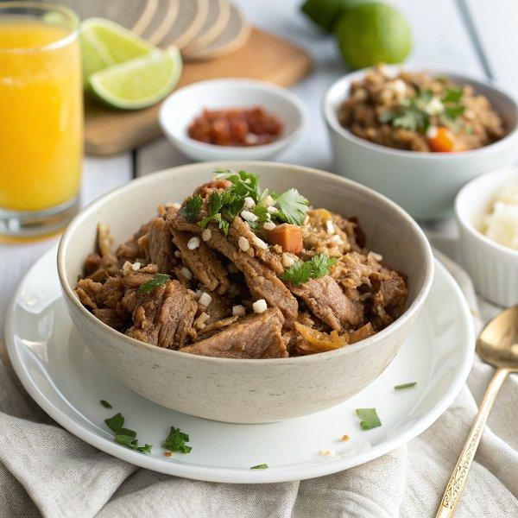

INGREDIENTS  - 3 to 4 lb boneless pork butt (Boston butt or pork shoulder, trimmed of excess fat and cut into 4 pieces)  - 2 tsp kosher salt (plus additional to taste)  - 1/2 cup freshly squeezed orange juice (from about 1 large orange)  - 3 cloves garlic (minced (about 1 tbsp)  - 2 tbsp apple cider vinegar  - 1 tbsp chipotle chile powder  - 2 tsp ground cumin  - 1 tsp chili powder  - 1 tsp dried oregano  - 1/2 tsp ground black pepper  - 1 14-oz can low sodium chicken broth, divided  - 1 tbsp extra virgin olive oil  - 1 yellow onion (diced)  - 1 jalapeño (stemmed, seeded and diced)  - Flour or corn tortillas (or cooked brown rice)  - Toppings of choice: chopped fresh cilantro (feta or queso fresco, sliced avocado, sliced or diced onion, diced jalapeño) | PREP  COOK  1. Salt  2. Season the pork on all sides with 2 teaspoons of the salt. Let sit for 30 minutes to come to room temperature.  3. Stir  4. In a mixing bowl or large measuring cup, stir together the orange juice, garlic, vinegar, chipotle chile powder, cumin, chili powder, oregano, and black pepper. Set aside.  5. Saute  6. Warm the oil in the Instant Pot, using the pot’s sauté function. Add the onion and jalapeño. Cook until the onion is beginning to soften, about 5 minutes.  7. Broth  8. Turn the Instant Pot off. Splash in about half of the broth. With a wooden spoon or sturdy spatula, remove any stuck-on bits of food (there may not be any, but if there are, they must be removed or the Instant Pot could register a BURN warning).  9. Pork  1  0. Add the pork, then pour in the remaining broth and the orange juice mixture. Turn the pork pieces to combine the ingredients and coat the pork evenly on all sides.  1  1. Cook  1  2. Close and seal the Instant Pot. Cook on HIGH pressure for 45 minutes. Once the pressure has built and the time has elapsed, let the pressure release naturally for 15 minutes.  1  3. Oven  1  4. Place a rack in the center of the oven and preheat the oven's broiler to high. Line a large rimmed baking sheet with foil.  1  5. Shred  1  6. With two forks, shred the pork directly in the Instant Pot, discarding any large bits of remaining fat. Stir the pork in the sauce to coat it evenly.  1  7. Tortillas  1  8. Use a spoon to scoop the pork onto the prepared baking sheet. Spread the pork into an even layer.  1  9. Broil the pork for 3 to 5 minutes, until the edges of the pork begin browning and crisping up (don't walk away! It can quickly start to burn).  2  0. To warm the tortillas, wrap them in foil and pop them into the oven’s center rack while the pork broils. Or, you can heat the tortillas in a dry skillet on the stove.  2  1. Toss  2  2. Remove the baking sheet from the oven. Lightly toss and stir the pork to expose unbroiled sides. Return the pan to the oven and broil for 3 to 5 minutes more (the meat should become nice and crispy at its edges). Enjoy hot, piled into warm tortillas or over rice with toppings of choice.  PLATING

