GARLIC BUTTER FISH  COOK TIME: 10 min  SOURCE:  #quick #comfort-food #seafood | 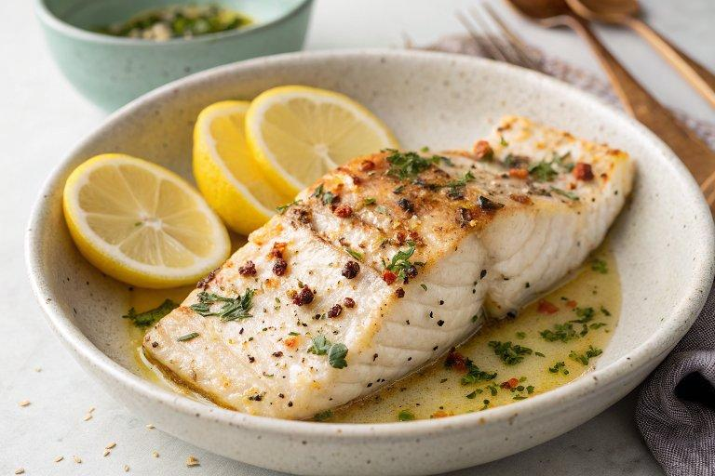

INGREDIENTS  - 12 oz. (350 g) firm white fish fillet (halibut, cod or pollock fillet)  - salt  - ground black pepper  - 3 dashes cayenne pepper  - 2 tbsp cornstarch  - 2 tbsp cooking oil  - lemon wedges  - 1/2 stick salted butter (4 tbsp, melted)  - 3 cloves garlic (minced)  - 1/2 tbsp lemon juice  - 1 tbsp chopped parsley | PREP  COOK  1. Cut the fish into pieces, not too thin, for easy pan-frying. Season the fish with salt, black pepper, and cayenne pepper. Coat the fish with cornstarch. Set aside.  2. Prepare the garlic butter sauce by mixing all the ingredients together. Set aside.  3. Heat a skillet (preferably non-stick) over medium heat. Add the cooking oil, and once the oil is heated, pan-fry the fish in a single layer until both sides are crispy and golden brown.  4. Use a wooden spatula or tongs to gently flip the fish over. Try not to break the fish.  5. Remove the fish from the skillet and drain on paper towels. Toss the fish with the garlic butter sauce and serve immediately with lemon wedges.  PLATING

