ONE-PAN TURKEY PASTA  COOK TIME: 20 min  SOURCE:  #quick #comfort-food #one-pan | 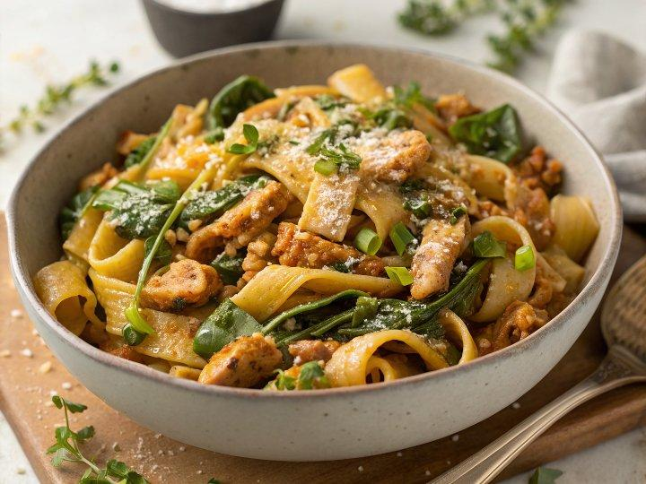

INGREDIENTS  - 160 g frozen spinach  - 1 leek  - 1/2 bunch of fresh thyme  - 250 g fresh lasagne sheets  - 150 g leftover turkey  - 100 g breadcrumbs  - 1 tbsp plain flour  - 300ml (1.2 cups) semi-skimmed milk  - 25 g Cheddar cheese (or any leftover cheese from your cheese board) | PREP  COOK  1. Take the spinach out of the freezer to defrost a little. Halve, wash and finely slice the leek and pick the thyme leaves. Cut the lasagne sheets lengthways into 3cm (1-inch) strips to create pappardelle.  2. In a dry casserole pan, toast the breadcrumbs with a few thyme leaves over a medium heat for 5 minutes. Tip into a small bowl, then place the pan back on the heat.  3. Drizzle ½ tablespoon of olive oil into the pan, add the leek and the rest of the thyme leaves along with a good splash of water and cook for 5-10 minutes over a medium heat, stirring occasionally until soft. Shred the turkey and add to the leeks.  4. Add 1 tablespoon of oil and stir in the flour, stirring for about a minute. Gradually add the milk and 300ml (1.2 cups) boiling water, stirring continuously until incorporated. Stir in the spinach and bring to the boil.  5. Once the spinach has broken up, reduce the heat and add the pasta. Simmer for 4 minutes, stirring occasionally so the pasta doesn’t stick together. Grate in most of the cheese to melt, then season to perfection, making sure the turkey is fully heated through.  6. Pile into two bowls, sprinkle over the toasted breadcrumbs, and dig in.  PLATING

