MEXICAN GRILLED CHICKEN TACOS  COOK TIME: 10 min  SOURCE:  #grilled #tacos #comfort-food | 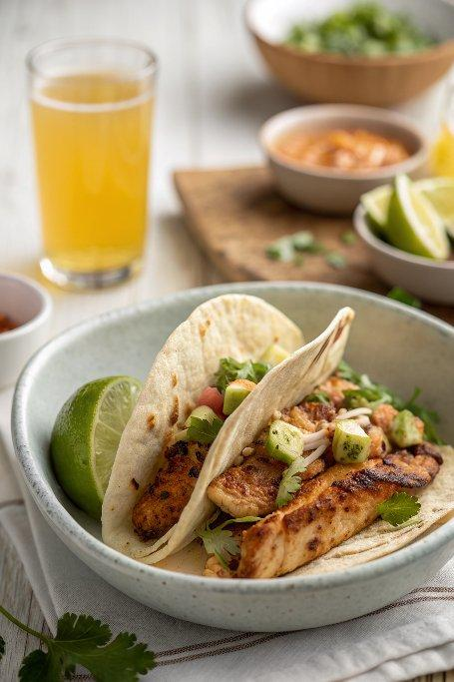

INGREDIENTS  - 1 - 1.5 lb / 500 - 750 g chicken thigh fillets (Note 2)  - 1 tbsp olive oil  - 4 tbsp orange juice  - 2 tbsp apple cider vinegar (or rice vinegar)  - 1 1/2 tbsp lime juice  - 3 garlic cloves (, minced)  - 1 1/2 tbsp chipotle or ancho chile powder (Note 3)  - 2 tsp dried oregano  - 2 tsp smoked paprika powder (Note 4)  - 1/8 tsp All Spice  - 1/4 tsp cinnamon powder  - 1/4 - 1/2 tsp cayenne pepper (optional - for spiciness)  - 1 tsp salt  - Black pepper  - Tortillas or taco shells  - Pico de Gallo (tomato salsa)  - Sour cream  - Avocado  - Fresh coriander / cilantro  - Lime wedges | PREP  COOK  1. Place Marinade ingredients in a ziplock bag. Add chicken, massage to coat then refrigerate to marinate for at least 3 hours, preferably overnight.  2. Remove chicken from Marinade, discard Marinade.  3. Heat oil in a skillet over medium high heat (or even better, do this on the BBQ on medium high). Cook chicken for 4 minutes on each side, until dark golden brown.  4. Remove chicken onto plate, cover loosely with foil and rest for 3 minutes.  5. Cut into strips and use for tacos. (See Note 5 for more serving options)  PLATING

