VEGAN NUTELLA ESPRESSO CHEESECAKE MOUSSE  COOK TIME: 10 min  SOURCE:  #chocolate #no-bake #creamy | 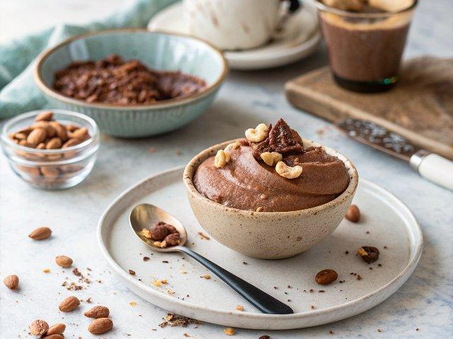

INGREDIENTS  - 1 1/4 cups raw cashews, (soaked for 8 hours or overnight and drained*)  - 1/2 cup canned full-fat coconut milk  - 3 tbsp coconut nectar or maple syrup  - 3 tbsp fresh lemon juice  - 1.5 tsp pure vanilla extract  - 1 tsp espresso powder  - A pinch of fine sea salt  - 2 cups (480ml) hazelnuts  - 1 tsp pure vanilla extract  - 1/4- 1/2 tsp fine sea salt, (to your taste)  - 2/3 cup oat milk (or another creamy plant-based milk)  - 4 oz 60% dark chocolate, (chopped)  - Ground cinnamon  - Flaky sea salt | PREP  COOK  1. Prepare the Espresso Cheesecake Mousse: Add the soaked cashews to a food processor or high-powered blender and blend for 30 seconds until broken down. Add the remaining ingredients for the mousse and blend until the mixture is smooth, thick, and creamy, scraping down the sides as needed. It will take a 2-3 minutes.  2. Refrigerate the mousse while you prepare the Nutella. It will thicken slightly.  3. Prepare the Nutella: Preheat the oven to 350°F/176°C (350°F). Place the hazelnuts on a rimmed baking tray and spread out evenly. Roast in the oven for 10 minutes or until lightly browned and very fragrant. Allow the hazelnuts to lightly cool.  4. Place the hazelnuts on top of a clean kitchen towel and wrap into a bowl. Rub vigorously to remove the hazelnut skins. It’s not necessary to remove all the skins.  5. Place the hazelnuts in a food processor or high-powered blender until it turns into nut butter. This can take up to 10 minutes depending on the quality of your food processor. Mine took only about 6-7 minutes.  6. While the hazelnuts are blending, prepare a double boiler. Add a few inches of water to a saucepan and bring to a simmer. Nestle a heatproof glass bowl that sits on top of the saucepan without touching the water to create a double boiler. Add the chopped chocolate, oat milk, vanilla, and sea salt to the bowl on top of the double boiler. Allow the chocolate mixture to melt, whisking frequently until smooth and all the chocolate pieces have melted.  7. Pour chocolate mixture into the food processor or blender with the hazelnut butter and briefly puree until smooth, creamy, and all the ingredients are incorporated.  8. When ready to serve, spoon a little Nutella into a glass, then layer the refrigerated espresso cheesecake mousse on top. Top with cinnamon and flaky sea salt, if desired.  PLATING

