ALMOND FLOUR  COOK TIME: 5 min  SOURCE:  #healthy #nut-based #gluten-free | 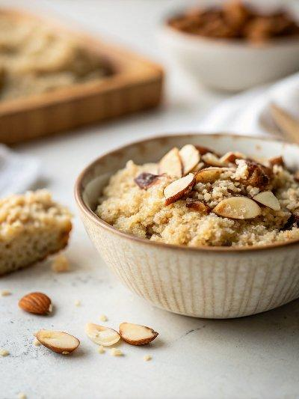

INGREDIENTS  - 1 1/2 cups slivered almonds | PREP  COOK  1. Blend the almonds in a high speed blender until they become a fine meal, about 10 seconds, depending on your blender.  2. Stir to loosen any large clumps or almond pieces near the base of the blender. Don't over-blend or your almonds will start turning into almond butter.  3. Use in any recipe that calls for almond flour or almond meal.  PLATING

