MEDITERRANEAN BROWN RICE AND TUNA BOWLS RECIPE  COOK TIME: 15 min  SOURCE:  #quick #healthy #protein-rich | 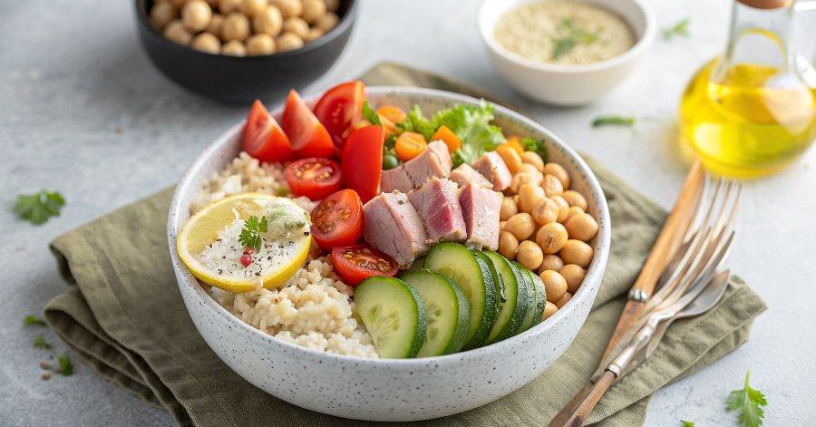

INGREDIENTS  - Greek Ladolemono dressing, (see the recipe)  - 1 cup (240ml) cherry tomatoes, (halved)  - 1/2 English cucumber, (cubed)  - 1 shallot, (halved and thinly sliced)  - 1 cup (240ml) canned chickpeas, (drained and rinsed)  - 1 cup (240ml) chopped fresh parsley  - Kosher salt and black pepper  - 2 cups (480ml) cooked brown rice, (follow package instructions for cooking. You will likely start with 1 dry cup of rice.)  - 2 6.7- oz jars of Tonnino Yellowfin Tuna Fillets in Olive Oil  - Feta cheese, (optional) | PREP  COOK  1. Make the ladolemono dressing according to this recipe.  2. Make the cucumber, tomato, and chickpea salad. In a medium mixing bowl, combine the tomatoes, cucumbers, chickpeas, shallots, and parsley. Season with kosher salt and black pepper and drizzle with about ¼ cup of the ladolemono dressing. Toss to combine and adjust seasoning.  3. Assemble the tuna bowls. Divide the brown rice, salad, and tuna fillets among 4 serving bowls. Top everything with a bit of the ladolemono dressing. Taste and adjust seasoning. If you like, finish with feta cheese.  PLATING

