ROASTED SWEET POTATOES & HUMMUS  COOK TIME: 30 min  SOURCE:  #healthy #quick #comfort-food | 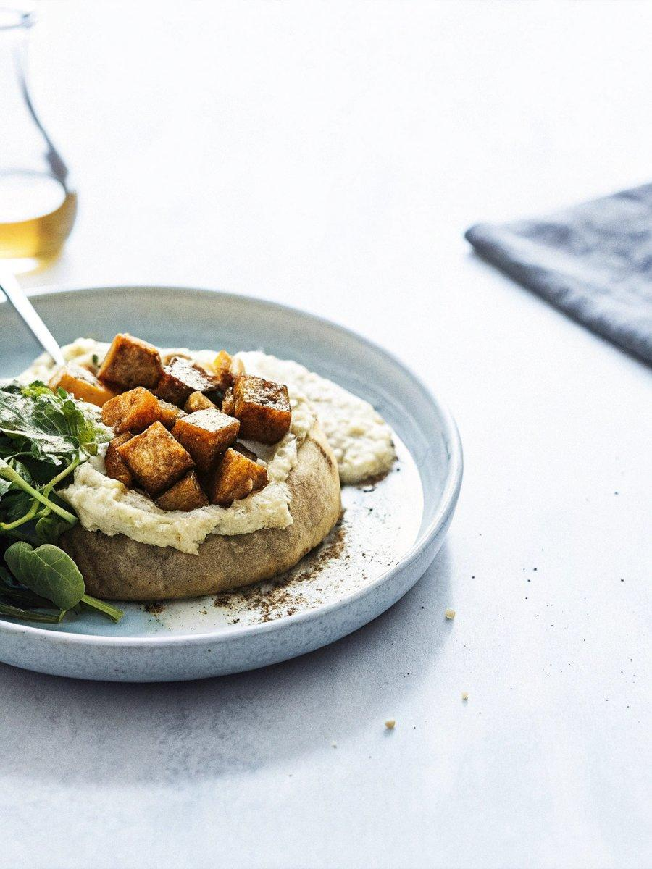

INGREDIENTS  - 1 sweet potato, diced  - 1 tbs. olive oil  - a generous sprinkling of seasoning (sel de cuisine for me!)  - 2 cups (480ml) fresh spinach, chopped  - 1 tbs. olive oil (again)  - a little more seasoning (again, sel de cuisine)  - crumbled or shredded white cheese  - hummus | PREP  COOK  1. Roast potatoes by tossing the first three ingredients. Place on a baking sheet or roasting pan and roast for 15-30 minutes, depending on the size of the pieces and the desired roastedness.  2. Toss the next four ingredients. Plate with a (large) spoonful of hummus. Remove sweet potatoes from the oven, check for doneness by eating a few, and then add half to each plate!  PLATING

