CHOCOLATE SOUFFLÉ RECIPE  COOK TIME: 15 min  SOURCE:  #chocolate #baking #elegant | 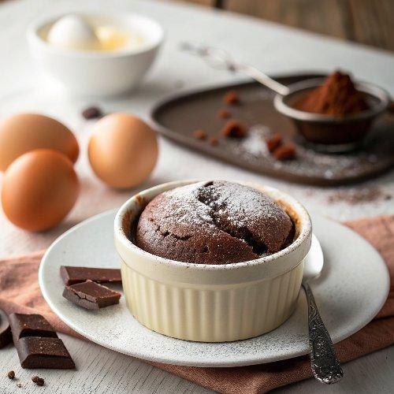

INGREDIENTS  - 1/2 cup unsalted butter (softened, plus more to coat the ramekins)  - 1/4 cup granulated sugar (plus more to coat the ramekins)  - 8 oz bittersweet chocolate (60-65% cacao, broken into small pieces or chopped)  - 1 tsp vanilla extract  - 6 large eggs (room temperature, separated)  - 1/4 tsp fine sea salt  - 1/2 tsp cream of tartar  - 1 cup (240ml) heavy whipping cream  - 2 Tbsp granulated sugar  - 2 tsp Grand Marnier or 1/2 tsp vanilla extract  - 1/3 cup whipping cream  - 1 Tbsp granulated sugar  - 1/2 tsp vanilla extract  - 2 oz semisweet or bittersweet chocolate (1/4 cup chips or chopped bars ) | PREP  COOK  1. Prep for Soufflé:  2. Preheat the oven to 400˚F with a rack in the lowest position of the oven. Be sure it’s fully preheated (an oven thermometer helps to make sure).  3. Brush the bottoms and sides of six 8-oz ramekins with softened butter, brushing the butter in an upwards motion on the sides of the ramekins to encourage rise. Coat the inside of the ramekins thoroughly with granulated sugar, turning the ramekin to coat the sides and tapping out the excess.  4. Add 2 cups (480ml) of water to a medium saucepan and bring to a simmer on the stove and adjust the heat to keep it at just a simmer.  5. How to Make Chocolate Soufflé:  6. In a large rimmed heatproof mixing bowl, combine chocolate and 8 Tbsp of softened butter. Place the bowl over the simmering water (it should just be over the steam and not touching the water) and stir occasionally with a spatula just until melted and combined. Remove from heat right away and set aside for 5 minutes to cool slightly then whisk in 6 yolks, 1 tsp vanilla, and 1/4 tsp salt until combined.  7. In a clean large mixing bowl, add 6 egg whites and 1/2 tsp cream of tartar and beat with an electric mixer on medium speed until soft peaks form (2 minutes). With the mixer on, gradually add the sugar then increase to high speed and beat until stiff peaks form and the mixture is glossy and shiny (2 to 2 1/2 minutes).  8. Fold 1/3 of the egg whites into the chocolate mixture to lighten it. Fold in the remaining egg whites in 2 additions. Fold scraping from the bottom of the bowl and turning the bowl as you go, just until incorporated and no streaks of whites remain.  9. Divide the mixture evenly between the prepared ramekins (using an ice cream scoop keeps this process tidy and easy).  1  0. Just before putting it into the oven, Run your thumb around the inside rim of the ruffle, creating a little border about 1/4” deep at the edges to encourage the center of the soufflé to rise.  1  1. Place on the bottom oven rack then immediately reduce heat to 375˚F and bake without opening the door for 13 -16 minutes. Once they have risen, they can be removed from the oven. Don't over-bake or they may crack on top.  1  2. To Make Whipped Cream:  1  3. Beat cream together with sugar and grand mariner on medium speed until soft peaks form then increase to high speed and beat until medium/stiff peaks form.  1  4. To Make Chocolate Sauce:  1  5. In a small saucepan, combine cream, sugar, and vanilla. Stir over medium heat until sugar dissolves then reduce heat to low and add chocolate, stirring until melted. Serve warm.  PLATING

