MAPLE QUINOA GRANOLA  COOK TIME: 40 min  SOURCE:  #healthy #quick #homemade | 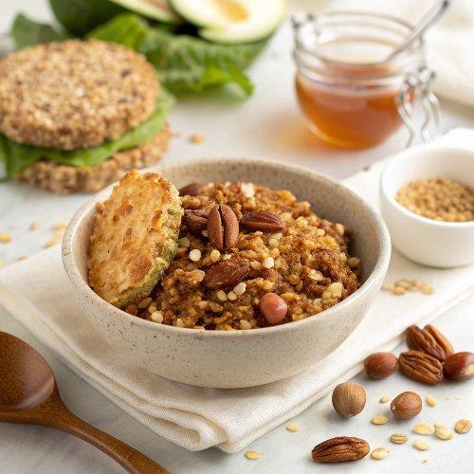

INGREDIENTS  - 2 1/3 cups old-fashioned oats  - 1/2 cup uncooked quinoa  - 1 cup (240ml) raw nuts (I did a mix of almonds and walnuts)  - 1/2 cup unsweetened shredded coconut  - 1/4 cup chia seeds  - 2 tsp ground cinnamon  - 1/2 tsp kosher salt  - 1/3 cup pure maple syrup  - 3 tbsp melted coconut oil or canola oil  - 3 tbsp unsulphured molasses (not blackstrap)  - 2 tsp pure vanilla extract  - 1 large egg white  - 3/4 cup mix-ins of choice: chocolate chips | PREP  COOK  1. Place a rack in the center of your oven and preheat to 300°F (150°C). Line a large rimmed baking sheet with parchment paper.  2. In a large bowl, stir together the oats, quinoa, nuts, coconut, chia seeds, cinnamon, and salt with a rubber spatula until combined. Pour in the maple syrup, oil, molasses, and vanilla. Stir to coat, until the dry ingredients are evenly moistened.  3. In a small bowl, briskly whisk the egg white with a fork or small whisk until it is foamy. Add it to the granola mixture and stir, doing your best to evenly incorporate the egg white throughout.  4. Carefully pour the granola onto the prepared baking sheet and spread into a single layer, pressing it down with the back of the spatula. Bake for 20 minutes, then remove the granola from the oven. With a large, ﬂexible spatula, carefully ﬂip large sections of the granola over, doing your best to keep them intact. With the back of the spatula, press the granola back into a single layer. Rotate the pan 180 degrees, return it to the oven, then bake for an additional 15 to 20 minutes, until the granola is golden brown, feels almost dry to the touch, and smells irresistible. It will continue to crisp as it cools.  5. Place the baking sheet on a cooling rack. Let the granola cool completely on the sheet (no cheating!), then carefully stir in the mix-ins, breaking up the granola as you do. Enjoy with milk, yogurt, overnight oats, over ice cream or frozen yogurt, or on its own by the handful.  PLATING

