CONDENSED MILK TRUFFLES  COOK TIME: 10 min  SOURCE:  #chocolate #no-bake #quick | 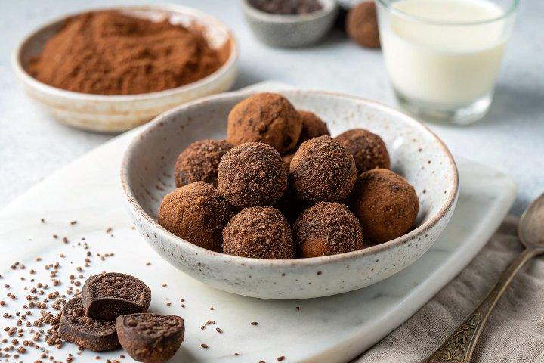

INGREDIENTS  - 180 g vegan condensed milk (see notes)  - 60-80 g cocoa powder (I used Dutch-processed) + more for coating) | PREP  COOK  1. You can watch the video for visual instructions.Line a small rectangular mold (mine measures 4.5x6.5 inches resp. 11.5x16.5 cm) with wax paper with an overhang on all sides (for easier removal).  2. Pour the condensed milk into a medium bowl. I used homemade vegan condensed milk.If it's too thick (i.e. if you stored it in the fridge), simply microwave it for a couple of seconds or warm it up in a double boiler until it's runny.  3. Sift in the cocoa powder in portions, stirring occasionally.  4. Once the mixture starts getting very thick, I recommend adding a bit of oil to your hands and kneading the dough until it's smooth.The dough should be soft, smooth, and manageable, but not sticky. If it's too wet, simply add more cocoa powder or freeze the mixture until you can handle it.  5. Transfer the dough to the prepared mold and spread it evenly with your fingers. Chill it for 1 hour in the refrigerator.  6. Once chilled, remove the dough from the mold and place it on a cutting board. Sift some cocoa powder over it, then cut it into squares using a sharp knife.  7. Either enjoy immediately or round off the edges of each square with your fingers (this step is optional).  PLATING

