SLOW COOKER BEEF TACOS  COOK TIME: 9h  SOURCE:  #slow-cooker #comfort-food #tacos | 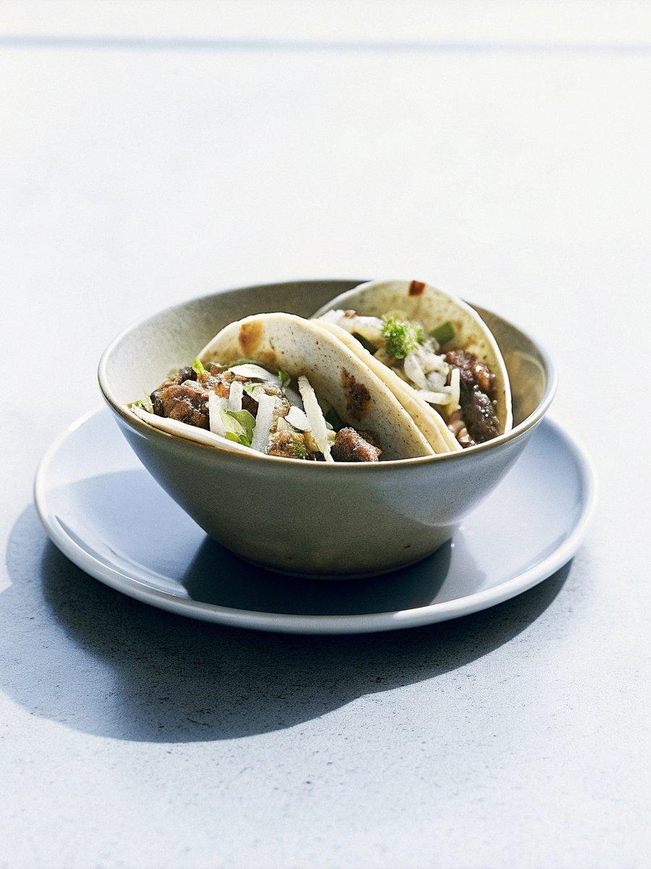

INGREDIENTS  - 1 tbsp vegetable oil  - 750 g-1 kg brisket cut into large chunks (about 6 cm pieces)  - 300ml (1.2 cups) beef stock  - 2 bay leaves  - 1 onion cut into wedges  - 2 vine tomatoes halved  - 2 garlic cloves  - 2 whole dried chipotle chillies soaked in 100 ml hot water, stems discarded (or use 2 tbsp chipotle paste)  - 1 tsp dried oregano  - 2 tsp ground cumin  - 1 tsp ground cinnamon  - 2 tbsp cider vinegar  - 1 tsp sea salt flakes  - 1/2 tsp ground black pepper  - small corn tortillas  - guacamole  - tomato salsa  - hot sauce  - lime wedges  - chopped coriander | PREP  COOK  1. If your slow cooker has a sear or sauté function, turn it to high. Alternatively, heat a frying pan over a high heat. For the spice paste, char the onion and tomato pieces for 6-8 mins until blackened slightly and starting to soften, turning every few minutes. This will impart a smoky flavour. Put these and the remaining paste ingredients in a food processor and blitz until smooth.  2. Heat the oil in the same hot pan or slow cooker and fry the brisket for 5-7 mins until golden brown on all sides. Tip in the spice paste and stir, frying for 2-3 mins until fragrant. Transfer to the slow cooker if you’ve used a pan. Pour over enough beef stock to cover the meat, then add the bay leaves and cover with the lid. Cook on low for 6-8 hrs until the meat is tender and shreds easily using two forks. Simmer, uncovered, for an extra 30 mins to reduce the sauce if needed. Check for seasoning.  3. Shred the meat and stir it back into the thickened sauce. Serve the beef in the tortillas along with any toppings you like, with lots of lime for squeezing over.  PLATING

