VEGAN RICE KRISPIE TREATS  COOK TIME: 5 min  SOURCE:  #quick #no-bake #sweet | 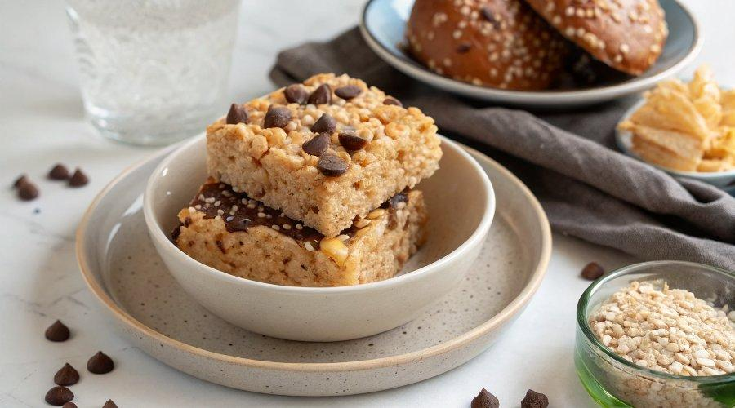

INGREDIENTS  - 4 cups (960ml) brown rice crisp cereal  - 1 cup (240ml) natural almond butter (or peanut butter)  - 1 cup (240ml) brown rice syrup  - 1/2 cup chocolate chips (I used Lily's)  - 1 tsp coconut oil | PREP  COOK  1. Prepare Pan  2. Line a 9x9 or 8x8 square baking dish with parchment paper or grease with cooking spray.  3. Measure rice cereal and place in a large bowl.  4. Combine  5. Place brown rice syrup and almond butter in a saucepan over low heat. Heat while stirring until mixture is combined and creamy, about 3 minutes.  6. Mix  7. Remove from heat and pour brown rice syrup mixture over the rice cereal and stir until all cereal pieces are well coated.  8. Transfer rice cereal mixture to the prepared baking dish and press down firmly with your hands.  9. Melt Chocolate  1  0. Add chocolate chips and coconut oil into a microwave-safe bowl and heat in the microwave using 30 second increments, stirring every 30 seconds, until chips are melted. It should only take 1-2 minutes. Once melted, add chocolate on top of rice krispie treats and spread so it creates an even layer.  1  1. Cool  1  2. Let cool in the fridge for 1 hour before cutting into squares and serving.  1  3. Store leftover treats in an airtight container in the fridge for up to a week.  PLATING

