THAI GREEN CHICKEN CURRY  COOK TIME: 30 min  SOURCE:  #quick #comfort-food #curry | 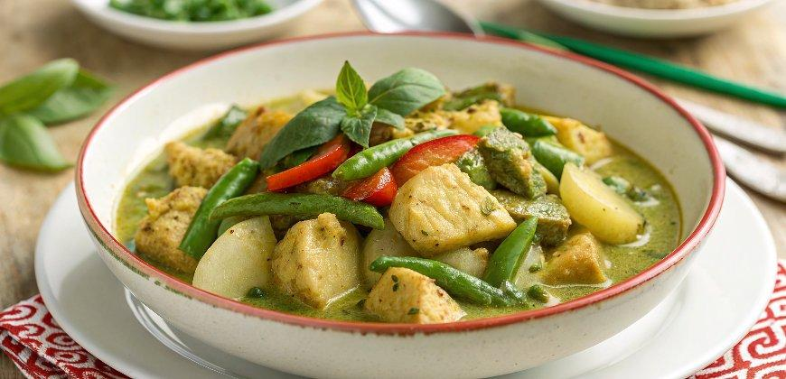

INGREDIENTS  - 225 g new potatoes cut into chunks  - 100 g green beans trimmed and halved  - 1 tbsp vegetable or sunflower oil  - 1 garlic clove chopped  - 1 rounded tbsp or 4 tsp Thai green curry paste (you can't fit the tbsp into some of the jars)  - 400ml (1.7 cups) can coconut milk  - 2 tsp Thai fish sauce  - 1 tsp caster sugar  - 450 g boneless skinless chicken (breasts or thighs), cut into bite-size pieces  - 2 lime leaves finely shredded, or 3 wide strips lime zest, plus extra to garnish  - good handful of basil leaves  - boiled rice to serve | PREP  COOK  1. Put 225g new potatoes, cut into chunks, in a pan of boiling water and cook for 5 minutes.  2. Add 100g trimmed and halved green beans and cook for a further 3 minutes, by which time both should be just tender but not too soft. Drain and put to one side.  3. In a wok or large frying pan, heat 1 tbsp vegetable or sunflower oil until very hot, then drop in 1 chopped garlic clove and cook until golden, this should take only a few seconds. Don’t let it go very dark or it will spoil the taste.  4. Spoon in 1 rounded tbsp Thai green curry paste and stir it around for a few seconds to begin to cook the spices and release all the flavours.  5. Next, pour in a 400ml (1.7 cups) can of coconut milk and let it come to a bubble.  6. Stir in 2 tsp Thai fish sauce and 1 tsp caster sugar, then 450g bite-size chicken pieces. Turn the heat down to a simmer and cook, covered, for about 8 minutes until the chicken is cooked.  7. Tip in the potatoes and beans and let them warm through in the hot coconut milk, then add 2 finely shredded lime leaves (or 3 wide strips lime zest).  8. Add a good handful basil leaves, but only leave them briefly on the heat or they will quickly lose their brightness.  9. Scatter with lime to garnish and serve immediately with boiled rice.  PLATING

