VEGAN LEMON GARLIC SOY CURLS  COOK TIME: 10 min  SOURCE:  #quick #comfort-food #plant-based | 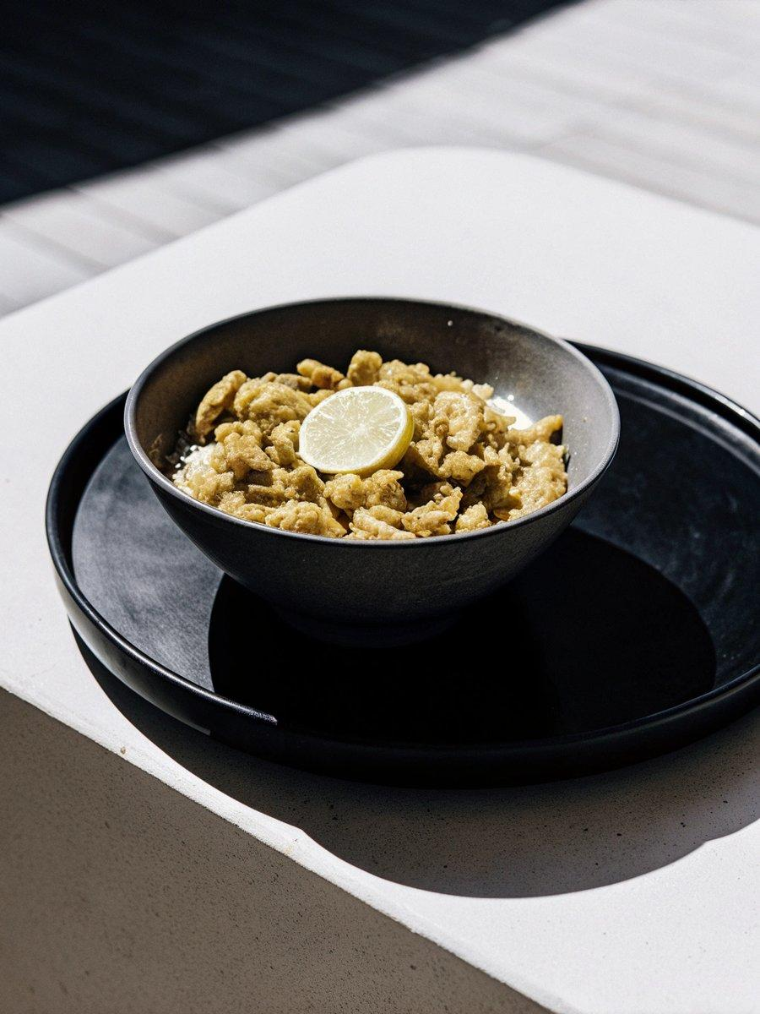

INGREDIENTS  - 2 cups (480ml) warm vegetable broth  - 2 lemons, (zested and juiced (about 6 tbsp juice))  - 6 cloves garlic, (minced or pressed)  - 2 tsp agave or maple syrup  - 1/2 tsp salt  - 1/2 tsp black pepper  - 2 cups (480ml) dry soy curls (4 oz)  - 1/2 cup all-purpose flour ((gluten-free if preferred))  - 2 tbsp light oil ((such as vegetable or canola))  - 1/2 cup plant-based milk ((see notes))  - chopped parsley for garnish | PREP  COOK  1. Warm the vegetable broth in the microwave or if using a vegetable broth powder (like I did) use warm water to prepare it. Combine all of the marinade ingredients together to a medium bowl. Add the soy curls and let soak for 10 minutes, stirring half way through to make sure all the soy curls get softened in the marinade.  2. Add the flour into another medium bowl and set aside. Remove the soy curls from marinade and squeeze them to release any extra liquid. Save the leftover marinade for later. It's ok if there are still little soy curl bits leftover in the marinade. Place the squeezed soy curls in the flour and toss to coat.  3. Heat the oil in a large skillet or frying pan. When hot, shake off the excess flour on the soy curls and add them to the pan. Fry, turning as needed until the soy curls are golden brown, about 5 minutes.  4. Pour over all of the remaining marinade and stir in the plant-based milk. bring to a simmer and cook for 3 - 5 minutes until the sauce has thickened.  5. Serve hot with sides of choice, over pasta, on rice, with mashed potatoes, or in any way you enjoy!  PLATING

