BALSAMIC ROASTED BRUSSELS SPROUTS WITH BACON  COOK TIME: 25 min  SOURCE:  #vegetable #comfort-food #bacon | 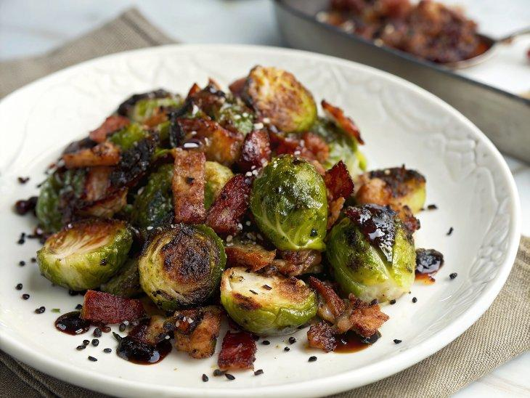

INGREDIENTS  - 1 1/2 lb Brussel sprouts (washed and dried)  - 4 oz bacon (diced, or pancetta)  - 1/4 cup good olive oil  - 4 cloves garlic (crushed or finely chopped)  - 1 tsp salt  - 1/2 tsp cracked pepper  - 2 tbsp balsamic glaze (or more to serve) | PREP  COOK  1. Preheat the oven to 425°F (220°C). Lightly grease a large baking pan with nonstick cooking oil spray or a light coating of oil. Set aside.  2. Trim the ends of sprouts and cut in half lengthwise.  3. Arrange brussels sprouts, any loose leaves, bacon and garlic on the pan. Drizzle with olive oil. Season with salt and pepper. Toss well and spread mixture out in a single layer.  4. Roast sprouts, turning once through cooking, until tender with charred edges. The bacon will be cooked and crispy (about for 25-30 minutes).  5. Toss with the balsamic vinegar. Adjust taste with extra salt and pepper, if needed.Serve immediately.  PLATING

