EASY HOMEMADE SPAGHETTI SAUCE RECIPE  COOK TIME: 25 min  SOURCE:  #quick #comfort-food #homemade | 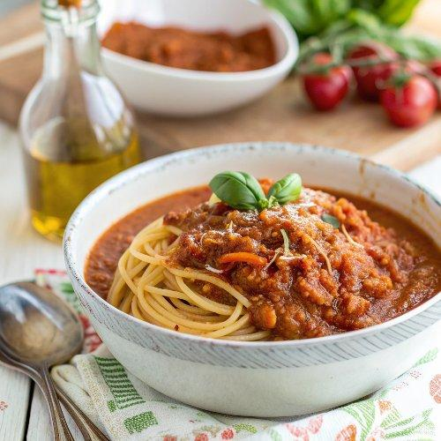

INGREDIENTS  - 1/4 cup extra virgin olive oil (I used Private Reserve Greek extra virgin olive oil)  - 1 medium yellow onion, grated  - 3 garlic cloves, finely minced  - 2 carrots, finely grated (use a food processor or a grater)  - 28 oz canned crushed tomatoes  - 1/2 cup water (pasta cooking water, preferred)  - Kosher salt and black pepper  - 1 tbsp dried oregano  - 1 tsp sweet Spanish paprika  - Pinch red pepper flakes, optional  - Handful fresh basil, about 1/2 cup packed, torn  - Handful fresh parsley, about 1/2 cup packed, chopped  - 3/4 lb to 1 lb of cooked pasta of your choice | PREP  COOK  1. In a large pan heat the extra virgin olive oil over medium heat until just shimmering. Add the onions, garlic, and finely grated carrots. Cook for about 5 minutes, stirring regularly until softened.  2. Add the crushed tomatoes and about 1/2 cup water. Add a generous pinch of salt and pepper. Stir in oregano, paprika, crushed pepper flakes, if using. Finally, stir in the fresh basil and parsley.  3. Bring the sauce to a boil, then turn heat to low. Cover and let simmer for about 15 to 20 minutes. Check partway through, and if you feel the sauce is too thick, you can add a bit more water (preferably some of your pasta cooking water). When sauce is ready, throw in more fresh basil, if you like.  4. If serving for dinner, add cooked pasta of your choice to the sauce. Mix to combine and let the pasta cook in the sauce over low heat for about 5 minutes.  PLATING

