MEATBALL & CHICKPEA YELLOW COCONUT CURRY WITH RICE & PICKLED RED CABBAGE  COOK TIME: 45 min  SOURCE:  #comfort-food #quick #curry | 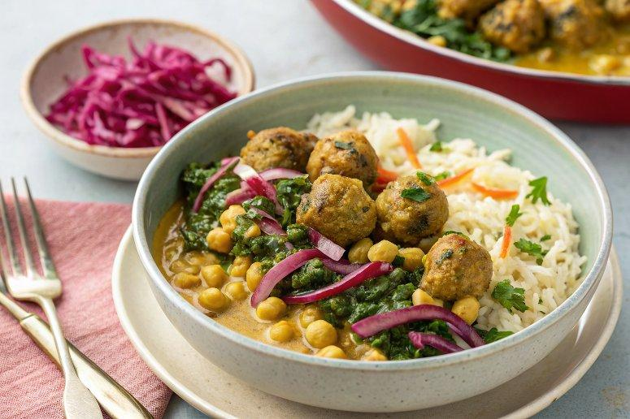

INGREDIENTS  - 2 tbsp vegetable oil  - 420 g spiced meatballs (see 'Complete the dish')  - 800ml (3.3 cups) yellow coconut curry sauce (see 'Complete the dish')  - 400 g can chickpeas drained and rinsed  - 1 large green pepper sliced  - 200 g mangetout  - jasmine rice  - pickled red cabbage (see 'Complete the dish')  - small handful of coriander leaves picked | PREP  COOK  1. Heat the oil in a large saucepan over a medium-high heat. Add the meatballs and fry for 6-8 mins until browned all over (they don’t need to be cooked through at this point).  2. Pour in the curry sauce, chickpeas and green pepper. Bring to a gentle simmer and cook for 15-20 mins until reduced and thickened.  3. Add the mangetout and simmer for a further 5 mins until the veg is tender. Serve over jasmine rice with a handful of pickled red cabbage on top and a sprinkling of coriander leaves.  PLATING

