SWEET N' SPICY CHICKEN BOWLS  COOK TIME: 35 min  SOURCE:  #quick #comfort-food #spicy | 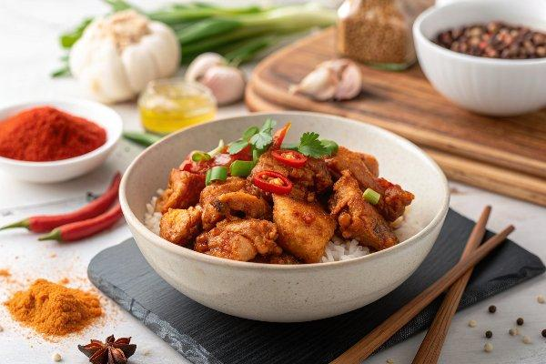

INGREDIENTS  - 1 tsp mild chili powder ($0.10)  - 1/2 tsp ground cumin ($0.05)  - 1/4 tsp garlic powder ($0.03)  - 1/4 tsp smoked paprika ($0.03)  - 1/8 tsp cayenne pepper ($0.02)  - Freshly Cracked black Pepper to taste ($0.05)  - 1/4 tsp salt ($0.02)  - 1 Tbsp olive oil ($0.16)  - 1 Tbsp honey ($0.12)  - 1/2 tsp apple cider vinegar ($0.02)  - 1 cup (240ml) uncooked brown rice ($0.60*)  - 1 3/4 cup chicken broth ($0.26)  - 1 boneless skinless chicken breast (about 3/4 lb.) ($1.49**)  - 1 8 oz. can pineapple tidbits in juice ($0.86)  - 1 15 oz. can black beans ($0.84)  - 1 ripe avocado ($0.98)  - 2 green onions ($0.22)  - 1/4 bunch fresh cilantro (optional) ($0.20) | PREP  COOK  1. Begin by cooking the rice. Combine the uncooked rice and chicken broth in a small pot. Place a lid on top and bring to a boil over high heat. As soon as it reaches a full boil, turn the heat down to low and let simmer for 25 minutes. After 25 minutes, turn the heat off and let it sit undisturbed, with the lid in place for 10 minutes. Fluff with a fork.  2. Prepare the honey spice mix by combining the chili powder cumin, garlic, smoked paprika, cayenne, freshly cracked pepper, salt, honey, olive oil, and apple cider vinegar in a bowl.  3. Chop the chicken breast into small pieces. Add it to the bowl with the honey spice mix and toss to coat. Set the seasoned meat aside while you prepare the rest of the bowl ingredients.  4. Rinse and drain the black beans. Drain the pineapple, then chop the tidbits into smaller pieces. Slice the green onions. Rinse and roughly chop the cilantro. Cut the avocado in half, then use a pairing knife to slice or cube the flesh.  5. Heat a large non-stick skillet over medium heat. Add the chopped and seasoned chicken pieces and sauté until cooked through and slightly browned (5-7 minutes).  6. Build the bowls by adding 3/4 cup cooked rice to each bowl, followed by 1/4 of each of the following: cooked chicken, black beans, pineapple, avocado, green onions, and cilantro.  PLATING

