FETTUCCINI WITH WINTER GREENS AND POACHED EGG  COOK TIME: 15 min  SOURCE:  #comfort-food #pasta #quick | 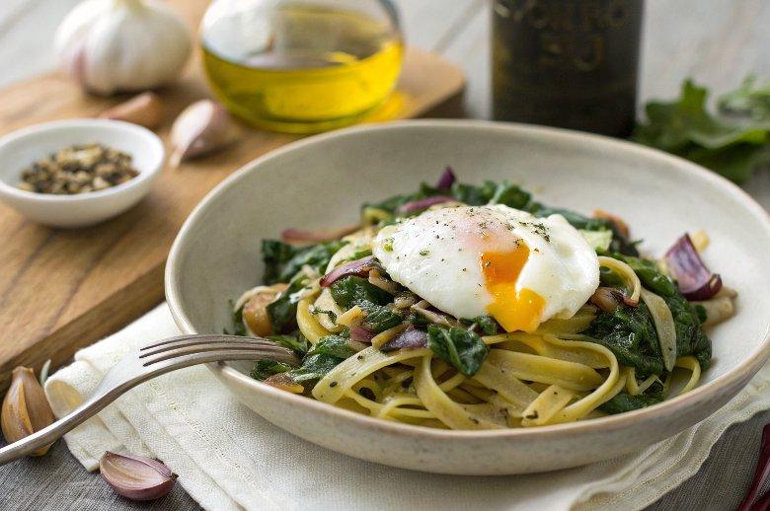

INGREDIENTS  - 4 oz egg fettuccini  - 1/2 tbsp olive oil  - 1/2 small red onion (sliced thin)  - 1/4 tsp kosher salt  - 1 clove garlic (chopped)  - 1 sprig Fresh thyme (leaves stripped from stem)  - 4 oz 4 cups (960ml) chopped winter greens, such as chard, escarole, spinach or kale  - 2 large eggs  - fresh shaved Parmesan (optional for serving) | PREP  COOK  1. Bring a medium pot of salted water to a boil. Add the pasta and cook according to package directions for al dente. Drain, reserving 1 cup (240ml) of the cooking water.  2. Meanwhile, to poach the eggs fill a large deep skillet with about 1 1/2 to 2-inch (5cm) of water and bring to a boil, then reduce to a simmer. Crack the eggs into individual bowls. Gently slide eggs one at a time into the simmering water. Using a spoon, gently nudge the egg whites toward center of yolk. Cook for 2-3 minutes for a semi-soft yolk or 3-4 minutes for a firmer-set yolk. With a slotted spoon or spatula, remove eggs one at a time and drain on paper towels.  3. While the pasta and eggs cook, in a large pan over medium-high heat, add the oil, red onion, season with 1/8th tsp salt, and cook, stirring occasionally, until starting to caramelize, about 3 minutes. Stir in the garlic and thyme and cook over medium-high heat until fragrant, about 1 minute.  4. Add the greens and 3/4 cup of the reserved cooking water. Bring to a boil, reduce to a simmer, and cook until the greens turn bright green and are just tender, 2 to 3 minutes. Stir in the pasta and cook until heated through, 1 minute. Remove from the heat and season to taste with salt and pepper.  5. Transfer the pasta to two individual bowls, about 1 1/2 cups each. Top with the egg and serve with grated cheese and fresh cracked pepper, if desired.  PLATING

