NO-WASTE PEANUT & SQUASH CURRY  COOK TIME: 45 min  SOURCE:  #comfort-food #curry #one-pot | 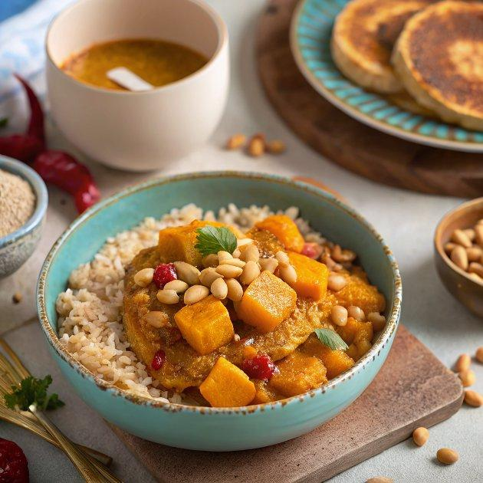

INGREDIENTS  - 185 g brown rice  - 50 ml olive oil plus 1 tsp  - 2 tbsp roasted salted peanuts roughly chopped  - 1 tsp chilli flakes  - 200 g block tempeh cut into 2.5cm (2-inch) cubes  - 1 small butternut squash unpeeled and halved  - 1 leek halved and finely sliced  - 2 tsp ground cumin  - 400ml (1.7 cups) can coconut milk  - 2 tbsp smooth peanut butter  - 200 g long-stemmed broccoli | PREP  COOK  1. Cook the rice following pack instructions. Pour half the oil into a frying pan with the peanuts. Put over a medium heat and let it warm up. Stir occasionally and, once the peanuts start to take on some colour, stir in the chilli flakes, then remove from the heat. Set a sieve over a heatproof bowl and strain the liquid through. Reserve both the oil and the contents of the sieve.  2. Heat the oven to 200C/180C fan/gas  6. Put the pan back over a medium heat and pour in half of the reserved chilli oil. Add the tempeh, and brown on each side for 2-3 mins, then flip and repeat. Set aside. Meanwhile, scrape the seeds out from inside the butternut squash and put in a sieve. Rinse under cold water to remove any stringy bits of flesh. Spread out on a piece of kitchen paper and pat dry. Tip onto a baking tray with 1 tsp of the olive oil and a good pinch of salt. Roast for 10-15 mins, until golden and crispy. Cut the remaining squash into 2.5cm (2-inch) cubes and set aside.  3. Heat the remaining chilli oil in the frying pan over a medium heat. Mix in the leek and cook for 5-6 mins until slightly browned, then stir in the cumin and butternut squash, and season well. Cook for 2-3 mins, then pour in the coconut milk and fill the can halfway with water, then pour in along with the tempeh. Add the peanut butter and stir well, ensuring the peanut butter is dissolved. Bring to a simmer, then cover and cook for 20 mins.  4. Scatter the broccoli over the top of the curry, then cover and leave to simmer for a further 10-15 mins. The broccoli and squash should be tender when pierced with a knife. Serve with the rice and scatter over the reserved chilli and peanuts, and the roasted squash seeds.  PLATING

