LION'S HEAD MEATBALLS  COOK TIME: 40 min  SOURCE:  #comfort-food #meatballs #asian-cuisine | 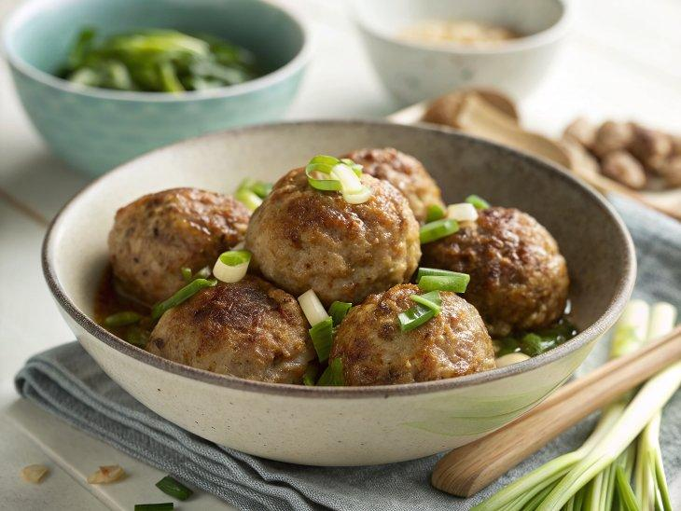

INGREDIENTS  - 1 lb fatty ground pork (450 g)  - 1 slice ginger (8 g, minced)  - 1 scallion (minced)  - 1 large egg  - 3 tbsp plain breadcrumbs (25 g)  - 1 tbsp Shaoxing wine  - 1 tbsp light soy sauce  - 1 tbsp oyster sauce  - 1/2 tsp white pepper  - 1/4 tsp five spice powder  - 1 1/2 tsp cornstarch  - 1/4 cup water  - 3.5 oz water chestnuts (100 g, canned)  - vegetable oil (to fry the meatballs)  - 1 tbsp vegetable oil  - 2 slices ginger  - 2 scallions (cut into 2-inch lengths, white and green parts separated)  - 10 g rock sugar (or 2.5 packed tsp brown sugar)  - 1 tbsp Shaoxing wine  - 1 1/2 tbsp light soy sauce  - 1/4 tsp dark soy sauce  - 1 tbsp oyster sauce  - 1 1/2 cups water  - 1 tsp cornstarch (mixed into a slurry with 1 tbsp water)  - 1/4 tsp sesame oil  - baby bok choy (for serving, optional) | PREP  COOK  1. Make the meatballs:  2. Make sure to find fatty ground pork. You can choose a fatty piece of pork shoulder and have the butcher grind it, or use our hand-chopping method to grind your own. A 70/30 meat to fat ratio is best, but 80/20 is also acceptable. Transfer the ground pork to a large mixing bowl.  3. Add the minced ginger and scallions, egg, breadcrumbs, Shaoxing wine, light soy sauce, oyster sauce, white pepper, five spice powder, cornstarch, and water.  4. Whip everything in one direction for about 10 minutes, until the meat mixture resembles a paste. This step is very important to making sure the meatballs have the right texture and don’t fall apart during frying.  5. Smash the water chestnuts with the side of your cleaver or knife and finely mince them. Add to the meat mixture and continue to mix everything together for 5 more minutes. Use a rubber spatula to scrape everything together.  6. Heat enough oil to submerge the meatballs in a small, deep pot (a small pot requires less oil) to 350 degrees F/175°C (350°F). Just be sure there’s enough oil to cook the meatballs evenly, but that the oil will not overflow during frying.  7. With oiled hands, divide the meat mixture into 8 to 9 equal portions and shape each into a ball. Carefully lower the meatballs one at a time into the heated oil, and fry in batches (2 minutes per batch) until they’re evenly golden brown. Remove the par-cooked meatballs with a slotted spoon and set aside.  8. Make the sauce & braise:  9. Heat 1 tablespoon oil in a wok over low heat. Add the ginger and white parts of the scallions, and cook for 1 minute. Then add the sugar and cook until dissolved.  1  0. Add 1 tablespoon Shaoxing wine, 1 ½ tablespoons light soy sauce, 1/4 teaspoon dark soy sauce, 1 tablespoon oyster sauce and 1 ½ cup water. Stir and bring the liquid to a boil.  1  1. Once boiling, add the fried meatballs. Cover and cook for 12-15 minutes over medium/low heat, flipping the meatballs halfway through.  1  2. After simmering, there should be about ¾ cup liquid left. Remove the meatballs from the liquid and arrange on your serving plate. (I served these with blanched baby bok choy. Just add a teaspoon or two of vegetable oil to boiling water for that “shiny” look, and blanch for 30 seconds).  1  3. Mix your cornstarch slurry, and pour into the sauce to thicken. Once it’s thick enough to coat the back of a spoon, stir in ¼ teaspoon sesame oil and the green parts of the scallions. Once the scallions are wilted, drizzle the sauce over the meatballs.  PLATING

