HOMEMADE OREOS  COOK TIME: 9 min  SOURCE:  #cookies #homemade #sweet | 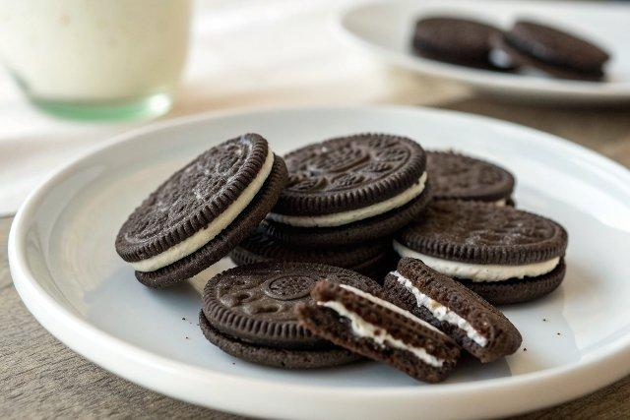

INGREDIENTS  - 1 and 1/4 cups (156 g) all-purpose flour (spooned & leveled)  - 1/2 cup (41 g) unsweetened Dutch-process cocoa powder (see Note if using natural cocoa)  - 1 tsp baking soda  - 1/8 tsp salt  - 1/2 cup (8 Tbsp; 113 g) unsalted butter, softened to room temperature  - 3/4 cup (150 g) granulated sugar  - 1/4 cup (50 g) packed light brown sugar  - 1 large egg, at room temperature  - 1 tsp pure vanilla extract  - 1/4 cup (4 Tbsp; 56 g) unsalted butter, softened to room temperature  - 1/4 cup (48 g) vegetable shortening, room temperature  - 1 and 3/4 cups (210 g) confectioners’ sugar  - 1 tsp pure vanilla extract | PREP  COOK  1. Make the cookies  2. Whisk the flour, cocoa powder, baking soda, and salt together in a large bowl. Set aside.  3. Using a handheld or stand mixer fitted with a paddle attachment, beat the butter, granulated sugar, and brown sugar on medium-high speed until combined and creamed, about 3 minutes. Scrape down the sides and the bottom of the bowl as needed. (Here’s a helpful tutorial if you need guidance on how to cream butter and sugar.) Beat in the egg and vanilla extract. Pour the dry ingredients into the wet ingredients and beat on low speed until a thick dough forms.  4. Line large baking sheets with parchment paper or silicone baking mats. Roll the dough into small balls, 2 teaspoons or 13–15g of dough each. Place the cookie dough balls on the lined baking sheets, and feel free to squeeze as many as you can onto one (since you’re refrigerating these and may not have space in your refrigerator for multiple baking sheets). Using the flat bottom of a measuring cup or drinking cup, flatten the balls into discs that are about 1.5-inch (13cm) in diameter (doesn’t need to be exact). Place the baking sheet(s) in the refrigerator for just 10 minutes to help set the cookies’ shape.  5. Meanwhile, preheat oven to 350°F (177°C).  6. Space the cold flattened cookies out to be 3-inch (8cm) apart on the baking sheets. There will be a couple batches of these cookies, so keep the shaped cookies in the refrigerator while the first batches bake. Bake for 8–10 minutes, or until the edges appear set and the tops are slightly cracking. Remove from the oven and allow to cool for at least 5 minutes on the baking sheets before transferring to a wire rack to cool completely.  7. While the cookies are cooling, make the filling  8. In a small bowl using a handheld or stand mixer with a paddle attachment, beat the butter and shortening together on high speed until totally combined and creamy, about 2 minutes. Add the confectioners’ sugar and vanilla. Beat on low speed for 1 minute and then switch to high and beat for 1–2 more minutes until creamy and combined. The filling is very thick.  9. Spread or pipe the cream filling on the bottom sides of half of the cookies. I usually use Wilton piping tip #  1  2. Sandwich the remaining unfrosted cookies on top of the cream filling, pressing down gently.  1  0. Cookies stay fresh covered at room temperature for up to 1 week.  PLATING

