BUTTERNUT SQUASH & MUSHROOM PUFF PASTRY TART  COOK TIME: 38 min  SOURCE:  #comfort-food #baking #seasonal | 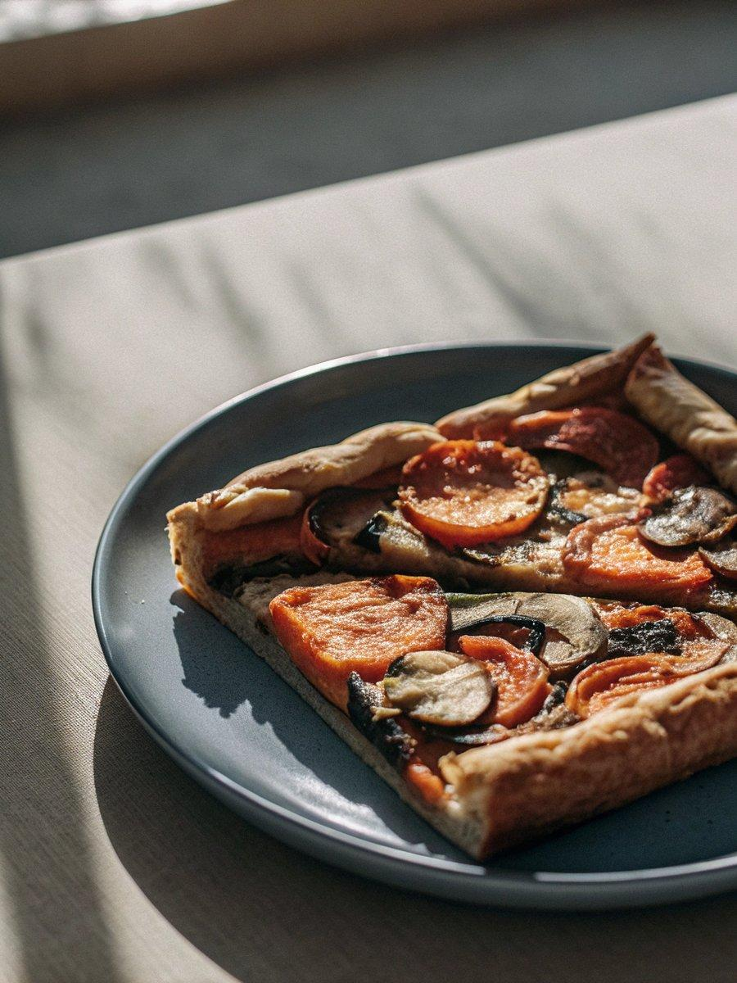

INGREDIENTS  - 1 lb homemade rough puff pastry or store-bought frozen & thawed puff pastry (2 sheets)  - egg wash: 1 large egg beaten with 1 tbsp (15 ml) water or milk  - 1 tbsp (15 ml) olive oil  - 2 cup (480ml)s (about 270 g) peeled & sliced butternut squash (1/4 inch slices)  - 1 and 1/4 cups (150 g) sliced or roughly chopped mushrooms  - 1/2 cup sliced onion (1/2 of a medium onion)  - 3 garlic cloves, minced  - 1/4 tsp salt  - pinch freshly ground black pepper, plus more for garnish  - 2 tsp fresh thyme leaves (or 1 tsp dried)  - 2 tsp chopped fresh rosemary (or 1 tsp dried)  - pinch ground nutmeg  - 1 cup (120 g) shredded parmesan cheese  - optional for garnish: flaky sea salt, pepper, more cheese, more fresh thyme & rosemary | PREP  COOK  1. Dough  2. Prepare homemade rough puff pastry dough through 2nd refrigeration. If using store-bought frozen puff pastry, make sure it’s thawed. Keep either dough in the refrigerator until step 4 below.  3. Topping  4. Over low-medium heat in a large skillet, cook oil and butternut squash together for 5 minutes stirring occasionally. Add mushrooms, onion, garlic, salt, pepper, thyme, rosemary, and nutmeg. Cook until vegetables are soft, about 5-6 minutes. Remove from heat.  5. Preheat oven to 400°F (204°C). Line a large baking sheet with parchment paper or a silicone baking mat. Set aside.  6. On a lightly floured work surface using a lightly floured rolling pin, roll pastry dough into a 10×16-inch (41cm) rectangle. (Tip if using store-bought—place the edge of one sheet over the other and use a rolling pin to adhere them together. Roll the whole thing out into a 10×16-inch rectangle.) Carefully transfer dough to lined baking sheet. If dough has lost shape, use your hands to reshape into a rectangle. Fold over a 1/2-inch (5cm) edge and crimp the edges down with a fork. Crimping is much easier the colder the pastry is, so place dough/baking sheet into the refrigerator to chill for 10 minutes if needed.  7. Egg Wash & Assemble  8. Brush egg wash all over puff pastry including the edges. Use a fork to poke holes all over the dough (not the crimped edge). Sprinkle with 3/4 cup (about 95g) cheese. Spoon vegetable topping over cheese and arrange in a single layer as best you can.  9. Bake tart for 30 minutes. Remove from the oven and sprinkle remaining cheese all over the top. Return to the oven and bake for 5-8 more minutes or until cheese is melted and pastry is golden brown.  1  0. Remove from the oven and, if desired, garnish with flaky sea salt, a sprinkle of pepper, and/or extra cheese and herbs. Slice and serve warm or at room temperature.  1  1. Cover and store leftovers in the refrigerator for up to 5 days. Reheat in the microwave or cover and bake in a 300°F (149°C) oven for 10-15 minutes.  PLATING

