AIR FRYER HARISSA SAUSAGE & VEG TRAYBAKE  COOK TIME: 45 min  SOURCE:  #quick #comfort-food #air-fryer | 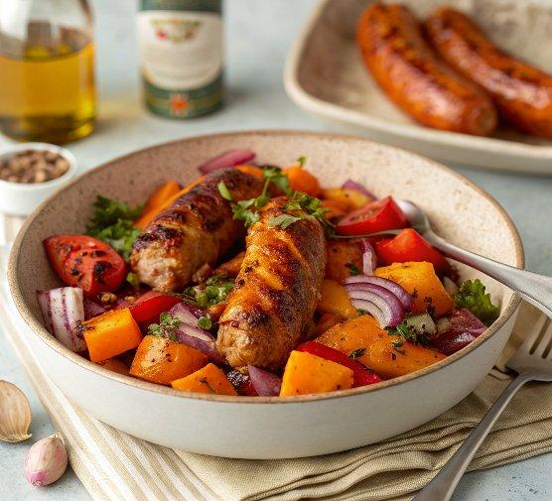

INGREDIENTS  - 1 small butternut squash roughly chopped (no need to peel)  - 1 1/2 tbsp rapeseed oil  - 1 red pepper roughly chopped  - 1 red onion cut into 8 wedges  - 4 garlic cloves lightly bashed  - 4-6 sausages  - 2-3 tbsp harissa to taste  - 1 lemon juiced  - 100 g dark green leaves (such as kale or cavolo nero), roughly sliced  - natural yogurt to serve (optional) | PREP  COOK  1. Heat the air fryer to 200C. Tip the squash into a bowl and toss in 1 tbsp oil and a good pinch of salt and pepper. Tip into the air fryer basket and cook for 10 mins.  2. Drizzle the remaining oil into the bowl you used previously and toss in the red peppers, onions and garlic. Tip into the air fryer basket and give everything a shake before cooking for a further 15 mins.  3. Put the sausages, harissa and lemon juice into the bowl and mix together. Add this to the air fryer basket, toss everything together and cook for 15 mins. Mix in the leaves and cook for another 5 mins. Serve with natural yogurt, if you like.  PLATING

