QUICK FISH CURRY  COOK TIME: 15 min  SOURCE:  #quick #comfort-food #curry | 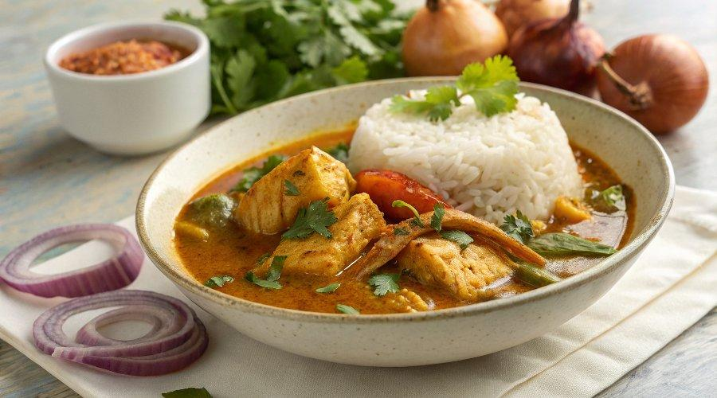

INGREDIENTS  - 1 mug of long grain rice (300 g)  - 6 whole cloves  - 1 onion  - 1/2 a bunch of fresh coriander (15 g)  - olive oil  - 3 heaped tbsp tikka masala curry paste  - 1 x 400 g tin of plum tomatoes  - 400 g frozen white fish fillets, from sustainable sources  - 150 g frozen green beans  - 1 x 400 g tin of light coconut milk  - 1 tsp runny honey | PREP  COOK  1. Place the rice in a 24cm (9-inch) non-stick frying pan with the cloves, 600ml (2.5 cups) of boiling water and a pinch of sea salt. Boil for 10 minutes, then cover and reduce to a low heat for 5 minutes, or until the base is golden and crispy and the rice is fluffy.  2. Peel and roughly chop the onion. Pick the coriander leaves into a bowl of iced water, and finely chop the stalks.  3. Place a large pan on a high heat with 1 tablespoon of olive oil, add the onion and coriander stalks, fry for 1 minute, then add the curry paste and fry for 2 minutes, stirring constantly.  4. Push the onion to one side, then tip the tomatoes into the other, breaking them up with a spoon. Leave to blip away for 5 minutes, stirring the onions occasionally, then stir everything together to make a sauce. Add the fish and stir again to coat.  5. Break in the beans, tear in half the coriander leaves, then tip in half the coconut milk and bring back to a simmer.  6. Stir in the honey, then cook for a final 5 minutes, or until the beans are tender and the fish is flaky and cooked through, stirring occasionally.  7. Ripple the remaining coconut milk through the sauce, and tear over the remaining coriander leaves, then turn out the rice cake and serve up.  PLATING

