PESTO PINWHEELS  COOK TIME: 18 min  SOURCE:  #quick #finger-food #party-snack | 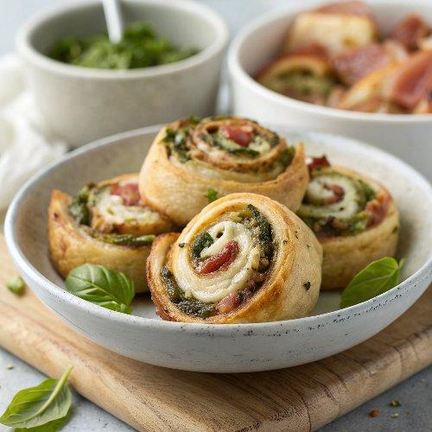

INGREDIENTS  - 2 sheets frozen puff pastry (thawed overnight in the refrigerator)  - 1/2 cup Basil Pesto (or flavored pesto of your choice or 1/4 cup each, divided)  - 10 slices prosciutto (divided (1, 5-oz packet)  - 1 1/2 cups freshly shredded Mozzarella cheese (divided)  - 4 tbsp grated Parmesan cheese (divided)  - Chopped fresh basil (optional for serving) | PREP  COOK  1. Roll  2. Unfold the first sheet of puff pastry on a work surface (if the pastry is sticky, lightly dust the work surface first). Roll it into a 10x12-inch (25x30cm) rectangle. Spread with 1/4 cup of pesto leaving a 1/2-inch (5cm) border on all sides. Lay 5 prosciutto slices on top, overlapping as needed. Sprinkle with 3/4 cup Mozzarella and 2 tablespoons Parmesan.  3. Wrap  4. Starting at the long (12-inch) edge, roll the puff pastry into a log. Press it lightly as you go so that the filling rolls inside the pastry. Trim the ends so that they are even, then tightly wrap the log with the plastic wrap. Place in the refrigerator for at least 20 minutes or up to 1 day. Repeat with the second sheet of puff pastry, and remaining pesto (if using 2 types of pesto, use the second variety here), prosciutto, and cheeses. Preheat your oven to 375°F (190°C) and line two baking sheets with parchment paper or silicone baking mats.  5. Bake  6. Once the logs have chilled, using a sharp, serrated knife, carefully cut each log into 1/2-inch (5cm)-wide slices. (If each log is 12 inches, you will get 24 rolls from each roll—if you are worried about the recipe yield, be sure to measure). Arrange the rolls on the baking sheet spiral-side up, spacing each 1-inch (3cm) apart. Bake until the puff pastry is flaky and golden brown and the cheese is hot and bubbly, about 18 minutes. Immediately sprinkle with chopped basil as desired. Let cool slightly. Serve warm or at room temperature.  PLATING

