SPINACH & ARTICHOKE PASTA  COOK TIME: 20 min  SOURCE:  #quick #comfort-food #pasta | 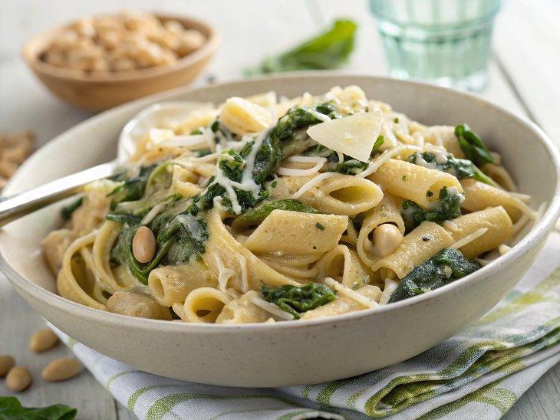

INGREDIENTS  - 3/4 cup whole grain pasta (I like shells)  - a handful of fresh spinach  - 2 tbs. Philadelphia Cooking Creme  - 1 tsp. minced garlic  - 1/2 cup canned artichoke hearts, quartered  - 1/2 cup white beans  - Parmesan cheese | PREP  COOK  1. Cook the pasta. Drain and return to pot. Keep heat on medium/low.  2. Add all ingredients except spinach. Stir until combined and heated through.  3. Stir in spinach until slightly wilted. Top with Parmesan and ground black pepper.  PLATING

