LEMON HONEY PORK RIBS  COOK TIME: 2h 26m  SOURCE:  #comfort-food #grilled #meat | 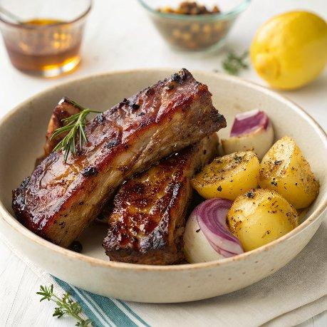

INGREDIENTS  - 2 red onions  - 1 large bulb of fennel  - 750 g waxy potatoes  - 1 bulb of garlic  - 1 lemon  - 4 tbsp runny honey  - 1.4 kg baby back ribs  - 1/2 a bunch of oregano (10 g) | PREP  COOK  1. Preheat the oven to 180°C (355°F). Boil the kettle. Put a large shallow casserole pan on a medium-high heat.  2. Peel and quarter the onions, trim and quarter the fennel, scrub and halve or quarter the potatoes, depending on their size, then place it all in the dry pan and cook for 10 minutes, or until starting to catch a little, stirring occasionally.  3. Break in the unpeeled garlic cloves, add 100ml of boiling kettle water, season with sea salt and black pepper and turn the heat up to high. Boil for a moment while you squeeze the lemon juice into a bowl with the honey, and put aside.  4. Halve the rib racks, drizzle with 1 tablespoon of olive oil, rub with a pinch of salt and pepper, then lay over the veg and push down, using them to create a lid. Transfer to the oven for 1 hour 30 minutes, turning the ribs halfway.  5. Pull out the pan, flip the ribs again and use the oregano bunch as a brush to spread the lemon honey all over them, then roughly chop and scatter over the oregano leaves.  6. Return to the oven, reduce the temperature to 150°C (300°F) and cook for a final 30 minutes, or until the meat is tender.  7. Remove the ribs to a board, then squeeze the garlic out of its skin and mash into the pan juices. I like it served with a nice green salad.  PLATING

