GREEN SMOOTHIE  COOK TIME: 5 min  SOURCE:  #healthy #quick #smoothie | 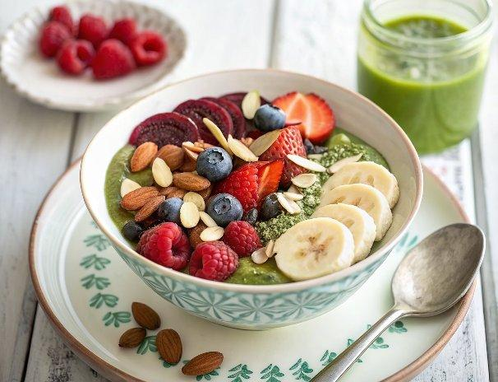

INGREDIENTS  - 3 Tbsp rolled oats  - 2 Tbsp sliced almonds or 1 Tbsp almond butter  - 1 medium ripe banana  - 1.25 oz. frozen raspberries or blueberries ((1/4 cup))  - 2 oz. frozen strawberries ((about 2 large or 6 small))  - 1/2 cup cold water*  - 2.5 oz. fresh spinach ((2 1/2 cups packed))  - 6 ice cubes  - 1/4 tsp cinnamon + 1/8 tsp vanilla extract (- for blueberry version)  - 1/8 tsp almond extract (- for raspberry version) | PREP  COOK  1. Add all ingredients to a high speed blender (if using blueberries add cinnamon and vanilla, if using raspberries add almond extract). Blend until well pureed. Serve immediately.  PLATING

