MANICOTTI RECIPE  COOK TIME: 35 min  SOURCE:  #comfort-food #pasta #baked | 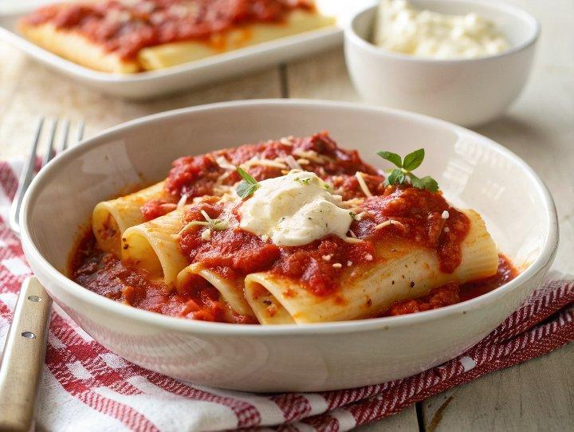

INGREDIENTS  - 8 oz Manicotti Pasta (14 ct)  - 3 cups (720ml) Marinara Sauce (homemade or store-bought)  - 1/4 cup heavy cream (optional (tones down acidity of marinara)  - 2 large eggs  - 24 oz whole milk ricotta cheese  - 2 cups (480ml) shredded mozzarella cheese (8 oz block, divided)  - 1 cup (240ml) freshly grated parmesan cheese (divided)  - 1/4 cup parsley (plus more for garnish)  - 2 garlic clove (grated or pressed)  - 3/4 tsp fine sea salt (plus more for pasta cooking water)  - 1/4 tsp freshly ground black pepper  - 1/4 tsp grated nutmeg | PREP  COOK  1. Preheat the oven to 400 degrees. Bring a large pot of water to a rolling boil with about 2 Tbsp Salt - add enough salt for it to taste like ocean water. Add pasta and cook until barely tender and extra al dente. I cooked for exactly 5 minutes. Remember it will continue cooking in the oven. Stir the pasta initially to prevent sticking. Drain pasta and immediately rinse under cold water to stop the cooking process then drain well.  2. Stir cream into your marinara then pour about 1 cup (240ml) of this sauce into a 9x13 casserole dish and tilt the pan to spread around the bottom.  3. In a large mixing bowl lightly beat 2 eggs then add ricotta, half of the mozzarella, half of the parmesan cheese, parsley, garlic, salt, tsp pepper, and nutmeg.  4. Transfer the mixture to a piping bag with a large round tip or use a large zip bag and cut off a 3/4” corner for piping. Fill all of the manicotti pasta and arrange them in a single layer in the prepared casserole dish.  5. Pour the remaining marinara over the top and top with the remaining mozzarella and parmesan. Cover with foil and bake covered for 25 minutes then uncover and bake another 10 minutes until cheese is melted and golden. Let stand 5 minutes before serving. Garnish with more parsley and serve.  PLATING

