VEGETARIAN ENCHILADAS  COOK TIME: 30 min  SOURCE:  #comfort-food #healthy #spicy | 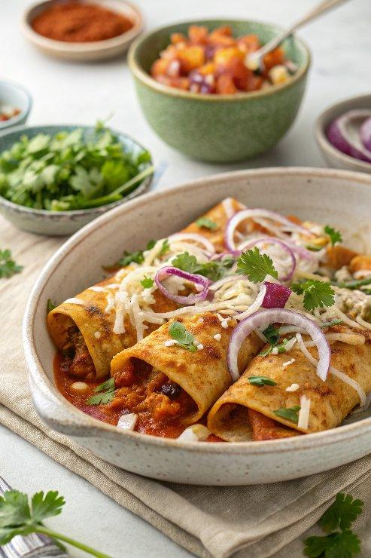

INGREDIENTS  - 1 tbsp extra-virgin olive oil  - 1 small red onion (diced)  - 3 1/2 cups (1/2-inch-cubed) butternut squash (about 1 small, 1 1/2-lb squash)  - 3 cloves garlic (minced (about 1 tbsp)  - 1 1/2 tsp ground chipotle chili powder (reduce to 1 or 1/2 tsp if sensitive to spice)  - 1/2 tsp ground cumin  - 1/2 tsp kosher salt  - 1/4 tsp ground black pepper  - 1 (15-oz) can low sodium black beans (rinsed and drained)  - 1 (10-oz) can red enchilada sauce  - 3/4 cup freshly grated sharp cheddar (Monterey jack, pepper jack, or similar cheese)  - 6 taco-sized (about 8-inch whole wheat low-carb tortillas (I used La Banderita brand)  - Optional | PREP  COOK  1. Preheat your oven to 375°F (190°C). Lightly coat a 9×13 baking dish with nonstick spray. Set aside.  2. Heat the olive oil in a large, deep skillet over medium. Once the oil is hot, add the onion and cook until beginning to soften, 2 to 3 minutes.  3. Stir in the squash, garlic, chipotle chili powder, cumin, salt, and pepper. Sauté until the squash is softened but still has a bit of chew, about 6 to 8 minutes, stirring occasionally. Taste a few pieces of the squash to make sure it’s the right texture overall. Stir in the beans, cooking just to warm through, about 30 seconds. Remove from the heat.  4. Fill  5. Spread a thin layer of the enchilada sauce into the bottom of the prepared baking dish. Fill the tortillas with a heaping 1/2 cup of the squash and bean filling, roll snugly, then arrange side by side in the dish, seam-side down. Pour the remaining sauce over the top, then sprinkle the top with cheese.  6. Bake for 20 to 25 minutes, until hot and bubbly. Let cool slightly, then serve with desired toppings.  PLATING

