KUNG PAO CAULIFLOWER  COOK TIME: 35 min  SOURCE:  #healthy #comfort-food #stir-fry | 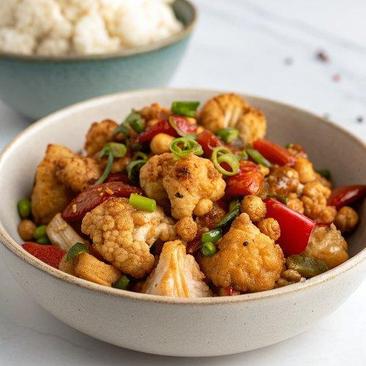

INGREDIENTS  - 1/2 cup chickpea flour (*see recipe notes)  - 4 tbsp cornstarch  - 1/2 cup plant-based milk  - 1/2 tbsp soy sauce (*see recipe notes)  - 1 medium head of cauliflower (cut into bite-sized florets)  - 1/2 cup of water  - 3 tbsp soy sauce (*see recipe notes)  - 2 tbsp rice vinegar  - 2 tbsp maple syrup (*see recipe notes)  - 1 tbsp cornstarch  - 1/2 tsp smoked paprika  - 1/4-1/3 tsp cayenne pepper (OR 4-6 dried chilies (*see recipe notes)  - 2 tsp oil (or water)  - 4 cloves garlic (minced)  - 1 tbsp fresh ginger (minced)  - 3/4 tsp peppercorns (optional)  - 1 small/medium bell pepper (sliced into fine strips)  - 1 tsp sesame seeds  - fresh chives (chopped)  - peanuts (optional) | PREP  COOK  1. This recipe has a video for easy visual instructions.  2. Batter:  3. Preheat oven to 425 degrees F (220 degrees C) and line a large baking sheet with parchment paper. In a large bowl whisk together cornstarch, chickpea flour, plant-based milk, and soy sauce. Let it sit for about 1 minute, then add the cauliflower florets.  4. Toss until all cauliflower florets are coated with batter. Transfer the cauliflower to the prepared baking sheet and bake in the oven for about 20 minutes  5. Skillet:  6. Heat oil (or water) in a skillet over low to medium heat, add garlic, ginger, peppercorns. Saute for 1 minute, stirring frequently to avoid burning.  7. Next, add bell pepper and saute with a lid on for a further 5-6 minutes, stirring frequently. Add more water if necessary (I used 1 tbsp).  8. Sauce:  9. Meanwhile, prepare the sauce. In a medium/large bowl, combine water, soy sauce, rice vinegar, sugar, cornstarch, smoked paprika, and cayenne. Whisk.  1  0. Pour the sauce into the skillet. Bring to a boil and let simmer on low heat for 1 minute. Add the roasted cauliflower florets and toss to coat.  1  1. Transfer back to the baking sheet and bake for a further 10-15 minutes if you like the cauliflower to be crispy OR enjoy immediately.  1  2. Serve with rice or rice noodles. Garnish with sesame seeds, fresh chives and peanuts (optional). Enjoy!  PLATING

