BREAKFAST BOWL WITH AMARANTH GRANOLA  COOK TIME: 30 min  SOURCE:  #healthy #quick #comfort-food | 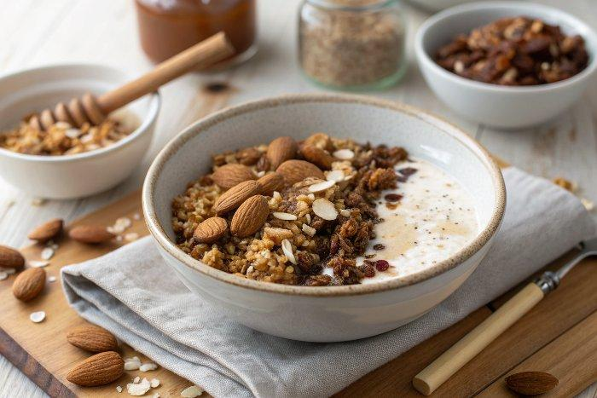

INGREDIENTS  - 1.5 cup (1200ml) rolled oats (not instant)*  - 1/2 cup amaranth  - 2/3 cup chopped almonds  - 2 tsp cinnamon  - 1/2 tsp salt  - 2 tbsp melted coconut oil  - 2 tbsp almond butter  - 4 tbsp maple syrup  - fresh, frozen or dried fruit (blueberries, tart cherries, etc)  - Almond Breeze Almondmilk Original | PREP  COOK  1. Preheat the oven to 300°F (150°C) and line a baking sheet with parchment paper.  2. In a medium bowl, mix together the oats, amaranth, almonds, cinnamon and salt. Add coconut oil, maple syrup and almond butter, and mix to incorporate.  3. Spread onto the baking sheet and bake for 15 minutes. Rotate the pan in the oven and bake for 15 minutes more, or until golden brown. Let cool for 15 minutes before serving.  4. Assemble bowls with granola, fruit and almond milk.  5. Store extra granola in an airtight container.  PLATING

