HAMBURGER STEAK BENTO  COOK TIME: 5 min  SOURCE:  #comfort-food #quick #rice | 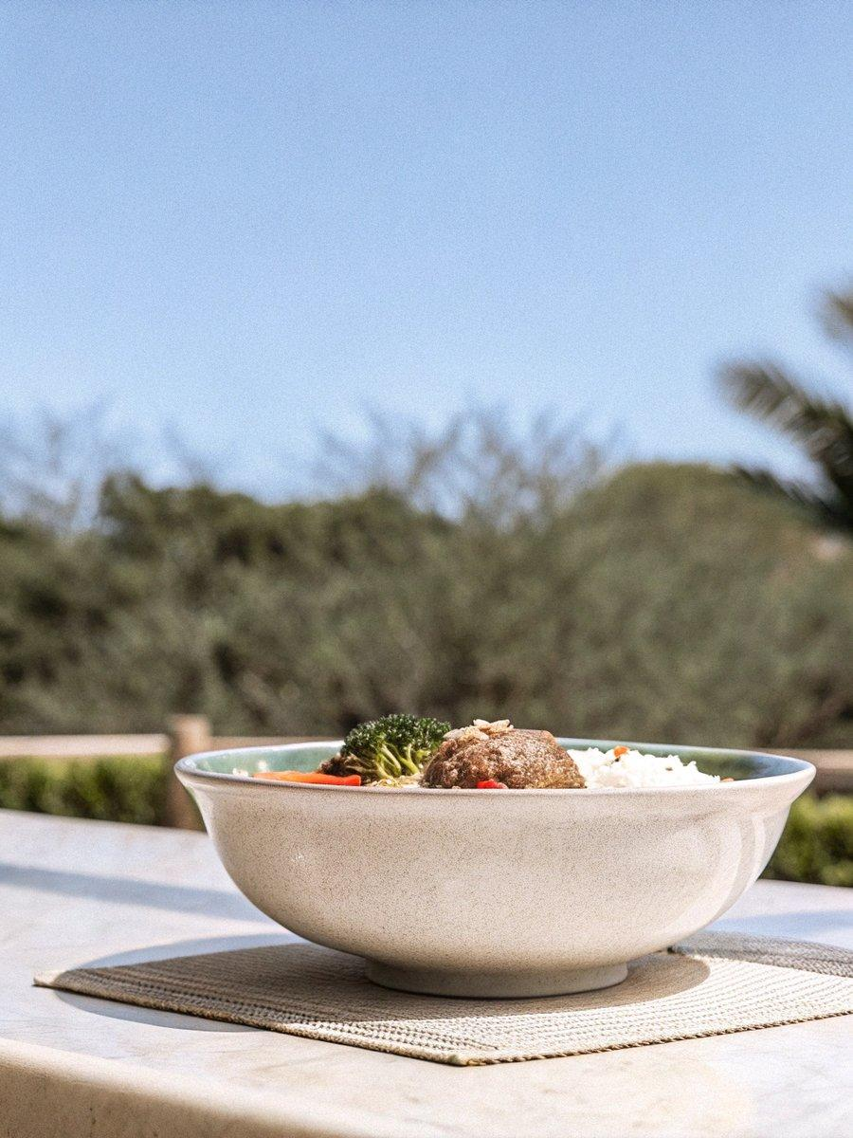

INGREDIENTS  - cooked Japanese short-grain rice  - hambagu (hamburger steak)  - broccoli (pre-blanched)  - tomato  - celery  - frozen or canned corn (cooked)  - furikake (rice seasoning) | PREP  COOK  1. Fill up half of the bento box with Japanese rice. Let it cool so that hot/warm rice will not warm up other cool food.  2. Reheat leftover hamburger steak in a frying pan until it's warm thoroughly.  3. Pack cooled Hamburger Steak in a silicone cup and put in bento box.  4. Place broccoli, tomato, celery, and corn in the bento box.  5. Sprinkle furikake on top of rice.  6. Let cool completely before closing the bento box.  PLATING

