GEMISTA (GREEK STUFFED VEGETABLES)  COOK TIME: 1h 30m  SOURCE:  #stuffed-vegetables #comfort-food #healthy | 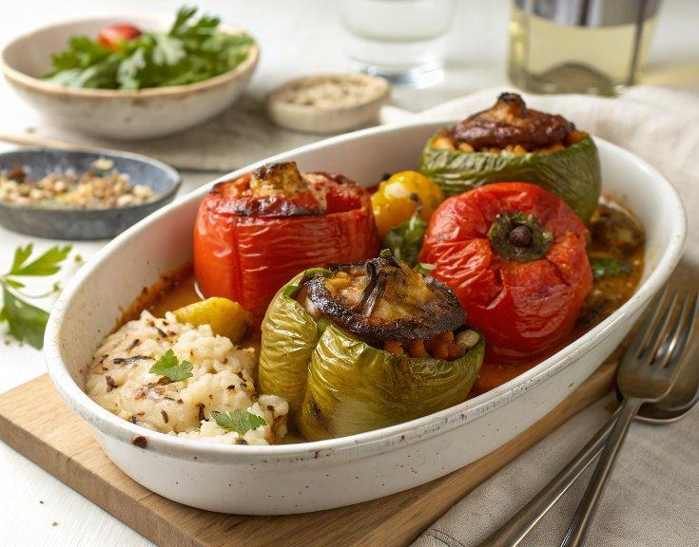

INGREDIENTS  - 4 large bell peppers (any color)  - 4 large tomatoes  - 6 Yukon gold potatoes, (cut into wedges)  - 3/4 cup basmati rice, (well-rinsed and drained)  - 1 large yellow onion, (chopped)  - 4 large garlic cloves, (minced (divided)  - 1/2 cup chopped fresh parsley  - 1/2 cup chopped fresh mint  - 1 1/2 tsp dried oregano (divided)  - 1/2 tsp paprika  - 1/2 cup crumbled feta cheese (optional)  - Extra virgin olive oil  - Kosher salt  - Ground black pepper  - 1 cup (8 oz) canned crushed tomatoes  - 1/2 cup water | PREP  COOK  1. Get ready. Preheat your oven to 375°F (190°C). Oil a large high-sided baking dish (9x13 or larger).  2. Hollow the bell peppers. Cut the tops off the peppers, about 1/2-inch (5cm) below the stem. Set the tops aside for later. Remove and discard the seeds from the peppers, then place them onto the prepared baking dish with the cut side up.  3. Hollow the tomatoes. Cut the tops off the tomatoes about 1/2-inch (5cm) below the stem. Set the tops aside for later. Use a small pairing knife to trace the edges of the tomato where the cells connect to the fruit. This will loosen and separate the inner flesh. Use a spoon to carefully scoop out inside into a medium mixing bowl, being careful to leave the “bowl” intact. Chop the larger pieces of flesh into chunks and return them to the mixing bowl. Place the hollowed out tomatoes in the baking dish next to the peppers. Tuck the potato wedges in between the bell peppers and tomatoes.  4. Make the rice filling. Into the bowl with the tomato flesh, add the (uncooked) rice, onion, half of the minced garlic, parsley, mint, 1/2 teaspoon oregano, paprika, feta cheese (if using), 1 tablespoon of olive oil, and a pinch of salt and pepper. Toss to combine.  5. Stuff the peppers and tomatoes. Spoon the rice filling into the hollowed vegetables, filling them about 3/4 of the way (remember, the rice will expand as it cooks). Place the reserved tops of the peppers and tomatoes on the vegetables like a lid.  6. Add the sauce. Spoon the crushed tomatoes all over the vegetables and follow with about a 1/2 cup of water. Sprinkle with the remaining garlic, 1 teaspoon oregano, and a big pinch of salt and pepper. Drizzle olive oil all over the vegetables.  7. Bake. Cover the baking dish tightly with foil and bake on the center rack of your heated oven for 1 hour. Uncover and bake until the rice filling is fully cooked and the vegetables are very soft and charred in some parts, about 30 minutes more.  8. Serve. Serve the stuffed vegetables with a drizzle of juices from the pan over top. Enjoy!  PLATING

